Name: ___________________

Whatever Next!

LO: To create own version of a familiar story

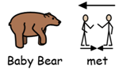

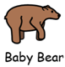

- Ask the children where baby bear went, they can choose Mars, Saturn or Neptune.
- Then ask who baby bear met was it an alien, dinosaur or a friend.
- Lastly, ask the children what did baby bear do did he play football, dance or did he explore?

