Speaking, Listening and Reading activities information and M levels covered
Dear Parent
In this folder there are a number of resources and activities that will promote learning within Speaking and Listening and then reading skills. Please look through these and access those that your child is comfortable with. The activities encourage the children to retell and recall elements of the story The 3 Billy Goats Gruff.
I have included a PowerPoint resource that will give you different option to my video version.
There are two sets of story sequencing cards to support you to retell to your child or for them to use to ‘read’ retell to you.
Below there are also several Small world ideas and props such as the character cut outs or Role Play Masks and play dough box ideas these may help you and your child play out the story. These would work well after accessing and completing the ‘build a bridge’ activity in the D & T folder too!
1. 3 Billy Goats Gruff collage and retelling activity
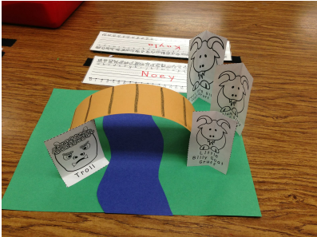
You will need
3 Billy goats retelling pictures sheet-In folder
A4 Green, blue and brown paper
Glue stick
Scissors
Pencil
To extend this activity there is also a Phonics Bridge game explained below, the board and resources are in the folder.
Phonics Bridge game
The letters can be changed to suit individual children. Write out your own letters on paper strips- letters from their name, or first 8 sounds from the phonics programme- (satpinmd) and use rather than ones attached to the game. Here are the rules
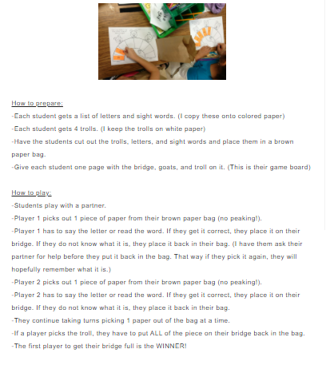
2. There are some readymade Role Play masks that you can print and cut out in this folder or below is a link to a make your own paper plate masks. Follow the link then scroll down the webpage to see the step by step instructions and resources list.
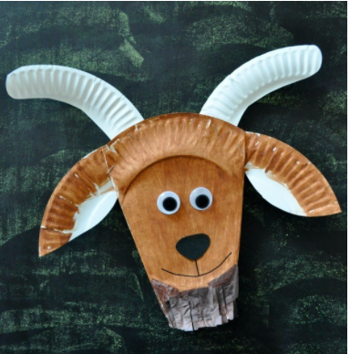 https://iheartcraftythings.com/three-billy-goats-gruff-craft.html

3. Create a play dough box
You and your child can re create your own versions of a troll using the resources and then play the story out.
You need
Play dough- see recipe in folder (Twinkl best play dough)
Lolly sticks or anything to create a bridge
String/cellotape/blu tac to join secure bridge pieces
Small stones, shapes pieces, rice/beans pasta or paper cut outs for teeth
Googly eyes or buttons
Goat characters
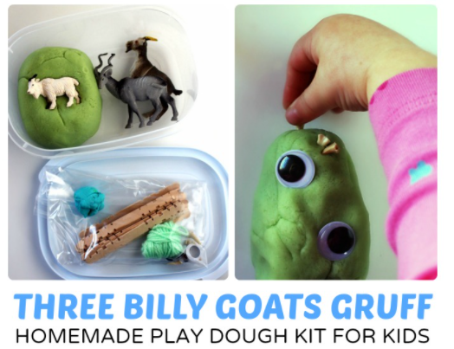

4. Make the field and scene with lego
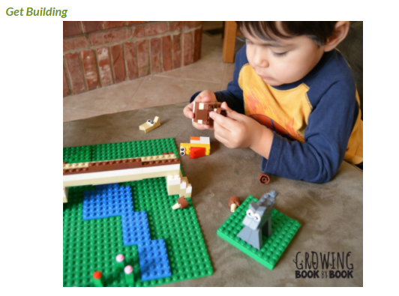
5. Learn and sing

The Three Goats song
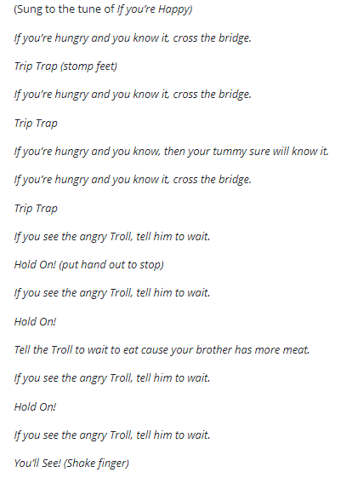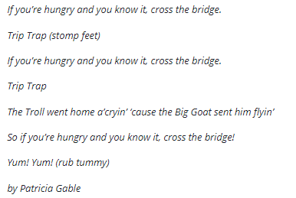

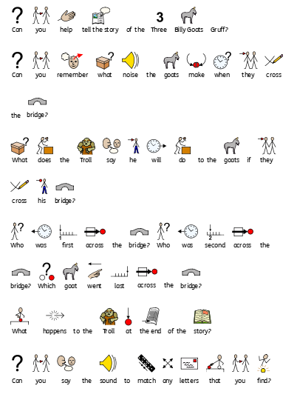

M levels
Speaking M6
-Pupils name objects which fall into familiar groups or catergories eg animals that live on a farm, colours, children in my class.
-Pupils use common prepositions correctly eg "in", "on".
-Pupils use familiar pronouns correctly eg "I", "it".
Listening M6
-Pupils respond to others in group situations, taking turns appropriately with support.
-Pupils demonstrate their understanding of common prepositions (in, on) by responding appropriately to instructions and requests containing them.
-Pupils recognise when a familiar rhyme song or story is dramatically changed and comment upon this.
-Pupils recognise and repeat the sound made by the initial letter of their name.
Reading M6
Pupils enjoy being a 'storyteller' and will mimic telling a story to others.
Speaking M7
-Pupils use phrases with up to three key words/signs/symbols to communicate ideas, events or stories to others.
- Pupils can suggest an appropriate word to complete a simple sentence.
- They contribute appropriately in 1:1 and small group discussions and role play.
Listening M7
- Pupils listen/ attend to and recall familiar repetitive short stories and rhymes.
- They attend to and respond to questions from adults and their peers about experiences, events and stories e.g. ‘Where has the boy gone?’
- Pupils make plausible predictions of words to complete a sentence, demonstrating they have listened to and comprehended what has been said
- Pupils attend to shared activities.
- Pupils participate in activities with a partner, listening and responding to the expressions/ communication of others.
-Pupils recognise and identify the sounds made by the first eight graphemes taught within the letters and sounds phonics programme. (Satpinmd)

Reading M7
-They predict elements of a narrative e.g. when the adult stops reading; pupils fill in the missing word.
Pupils answer a simple one or two keyword question about the text.
They understand the conventions of reading e.g. following text left to right, top to bottom and page following page.

Speaking M8
-Pupils link up to four key words/signs/symbols to communicate about their own experiences or tell a familiar story both in 1:1 situations and groups e.g "The hairy giant shouted at Finn".
- Pupils take part in role play, communicating their thoughts and feelings with an increasing confidence.
- Pupils sequence ideas appropriately within a spoken sentence or phrase.
Listening M8
-Pupils listen attentively to a range of speakers.
-Pupils are aware of when it is appropriate to attend rather than express.
-Pupils understand what is meant by the vocabulary 'first' and 'last'.
-Pupils follow requests and instructions containing four key words, signs, or symbols e.g. ‘Get the big book about dinosaurs from the library’.
-Pupils sequence words/symbols or pictures to recall stories and events that have been discussed.
-Pupils recognise that graphemes are represented by sounds and identify at least half the letters of the alphabet by their phoneme.
Reading M8
They recognise familiar letters of the alphabet by shape, name and sound.
Pupils associate a grapheme with a phoneme for the 3rd and 4th sets of letters taught within Phonics ( g, o, c, k, ck, e,u,r)
Pupils orally blend and segment the phonemes in CVC words

