Writing activity information and M levels covered
Please help your child to create a wanted poster for the Troll. There are 3 options for the posters with a varying amount of information. Choose the most appropriate to suit your son/daughter. This activity will also use lots of the speaking and listening skills that can be found in the Speaking and Listening folder. If your child finds cutting and drawing activities difficult then this can also help them develop these skills.
1. Create a picture of the Troll
This can be done with the use of the ‘Troll cut outs for wanted poster’ found in this folder or if they wish they can draw their own. If cutting to create help your child choose eyes, hair etc and cut them out and stick onto the chosen poster to create an image.
2. Follow the chosen poster to add details.
You can support your child by first asking them questions about their troll, use the posters to support you. Then you can help by writing their words/ideas for them to copy/ write in highlighter for them to overwrite or let them write and then you can scribe underneath if necessary.
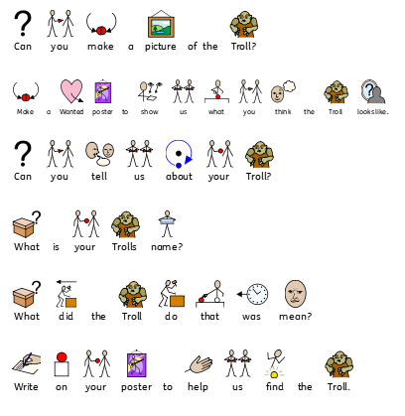

Learning level links for Writing
M6
They use writing tools with increasing control.
Pupils distinguish between 'print' and 'pictures'.
Pupils produce or write their name in recognised letter format.
They copy letter forms to convey meaning.
M7
Pupils know, through concrete ideas, what they intend to write.
Pupils are able to respond to a simple question about a piece of writing.
M8
They form their names with appropriate use of capital letters.
Pupils use mostly recognisable letter forms when writing.
Pupils show awareness that writing can have a range of purposes.

