Topics coming up in Lower School

All About Ware – Geography and History

Pupils are encouraged to learn about their school’s local area. Useful website for looking at old photographs of Ware through time is

<https://www.ourhertfordandware.org.uk/content/places/ware-places/ware-then-and-now>

where you can compare photographs of Ware years ago with current photographs of the High Street and the surrounding area. And

<https://www.hertsmemories.org.uk/content/category/herts-history/towns-and-villages/ware/page/2>

Encourage your child to think about the local area around school, can they think of what they see on their way to school?

What is new at school? Can you think of anything that has changed in the time they have been at school?

Also looking at photographs together of things you have done in the past. Encourage discussion about who you can see and what are they doing?

Habitats – Science

A very useful website is Twinkl – it is currently offering one month’s free premium membership to parents to download their resources.

For the topic of ‘habitats’ search for the resource ‘Introduction to Habitats’ this is a power point of a range of different habitats. Each habitat is a photograph which you can talk about and see if they can think of animals and plants they might see within it.

In addition you can search for different animals and their habitats. There are resources for ‘Woodland animals and their habitats’ ‘Mini beast habitats’ , ‘Under the sea habitats’ and ‘Arctic animals and their habitat’ Some of these have video content but all talk about a different group of animals and where they live.

3D models - Art / Design Technology

[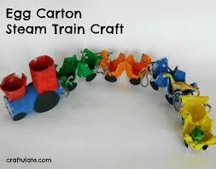](https://www.google.co.uk/url?sa=i&rct=j&q=&esrc=s&frm=1&source=images&cd=&cad=rja&uact=8&ved=&url=https%3A%2F%2Fcraftulate.com%2Fpage%2F3&psig=AFQjCNH-GrFVpR-AJOxiFo8wlOCoVwfqCQ&ust=1459858555589530)Create models using packaging found at home. Use cereal boxes, egg cartons to make train carriages, egg cartons to make a hungry caterpillar, make a model of your house or your school or a shop you know in Ware (link to topic)

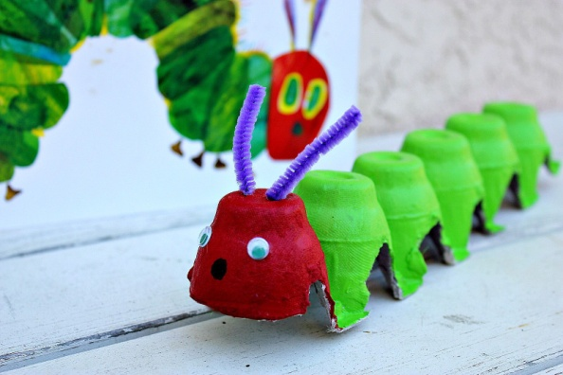

[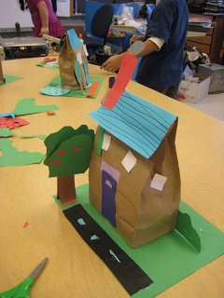](https://lh5.googleusercontent.com/-2YAiISROlxs/TWw_47o9sGI/AAAAAAAAEXg/Q54G5eUXT14/s1600/IMG_2758.jpg)Paper bag models of houses or shops.

Cbeebies ‘The Let’s Go Club’ has a range of arts and craft activities, messy play and also science activities ideas.

<https://www.bbc.co.uk/cbeebies/curations/the-lets-go-club-craft-activities>