Build Your Own Anderson Air Raid Shelter

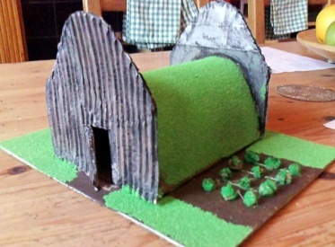

Each shelter has to be:
- able to fit a Lego figure (or similar) inside,
- able to withstand a 1kg weight placed upon it.

Suggestions for materials:
Empty cardboard tubes e.g. loo rolls or paper towel rolls
Empty boxes or containers
Corrugated paper
Empty tin can (make sure no sharp edges)
Coloured paper/card/tissue
Paint/felt pens/colouring pencils
Stones/twigs/leaves
Foil
Glue/sellotape/string/blu tak

Instructions:
- Look at different pictures of Anderson shelters to help you with ideas.
- Draw your design.
- Make a list of what materials you will need.
- Think how you will join the pieces together.
- Make your model – remember to check it can fit a figure inside.
- Test how strong it is.
- Take a photo and email it to school to go on our website.
karen.morgan@middleton.herts.sch.uk

