BEST EVER NO-COOK PLAY DOUGH RECIPE
You need:
- 2 cups plain flour (all purpose)
- 2 tablespoons vegetable oil (baby oil and coconut oil work too)
- 1/2 cup salt
- 2 tablespoons cream of tartar
- 1 to 1.5 cups boiling water (adding in increments until it feels just right)
- gel food colouring (optional)
- few drops glycerine (my secret ingredient for stretch and shine!)
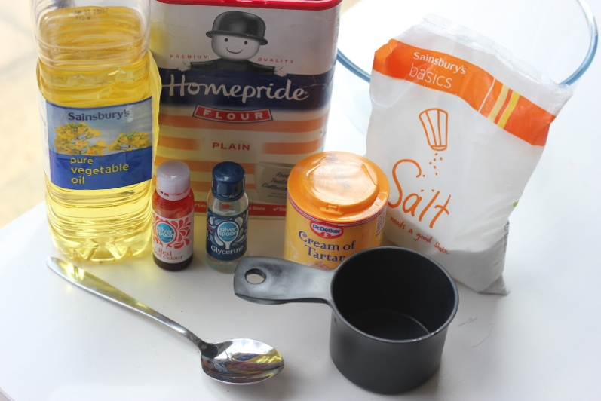
Method:
- Mix the flour, salt, cream of tartar and oil in a large mixing bowl
- Add food colouring TO the boiling water then into the dry ingredients
- Stir continuously until it becomes a sticky, combined dough
- Add the glycerine (optional)
- Allow it to cool down then take it out of the bowl and knead it vigorously for a couple of minutes until all of the stickiness has gone. * This is the most important part of the process, so keep at it until it’s the perfect consistency!*
- If it remains a little sticky then add a touch more flour until just right
Voila!
We use these Wilton Gel colours as they are much more vibrant and take only a tiny amount to colour the dough. We also use them in all our other sensory play activities to and they last for ever!
You can store this play dough in an air tight container for at least 6 months. If you live in a humid climate you might need to store it in the fridge and out of sunlight.

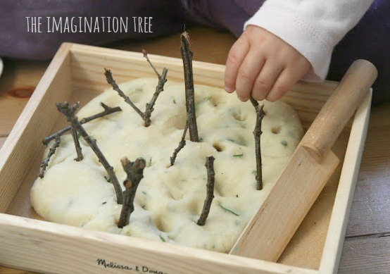

NATURAL HERBAL PLAYDOUGH
Ingredients:
- 1 cup salt
- 2 cups flour
- 1.5 cups boiling water
- 2 tbsp oil
- a few drops of fresh lemon juice (this works in the same way as cream of tartar!)
- fresh herbs eg rosemary, thyme, sage, oregano, mint (anything that smells nice and is not irritant!)
Mix all of the ingredients together in a bowl with a metal spoon. As soon as it is cool enough to touch, start kneading until it becomes soft, stretchy and pliable. Mix in the herbs. We used rosemary and lemon thyme from the garden.
Add some small twigs for pushing into the dough. It would also be lovely to introduce pebbles, grass, leaves, pine cone kernels and flower petals for adding a range of textures for exploration.
Store this in a zip-loc bag (air squeezed out first) in the cupboard. Some people suggest storing it in the fridge, but that seems to make my playdough go sticky over time. It should last up to a year at room temperature!
