Mimic a Painting Artist – Bridget Riley
Bridget Riley is a famous British painter. She was born in 1931 and is now 89 years old. Her first paintings were just ‘Black and White’ and then she used lots of different colours.
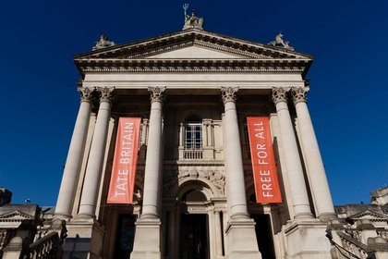
Her paintings are on display in the famous gallery in London called the Tate Gallery.

This is one of her paintings called ‘Late Morning.’ Do you like it?
You can mimic or copy her painting with pencils, crayons, paints, chalks or felt tips. Choose any colours you want and draw lines like Bridget Riley.
Here is one I have started to do.

