Mimic a Painting Artist – Jean Dubuffet

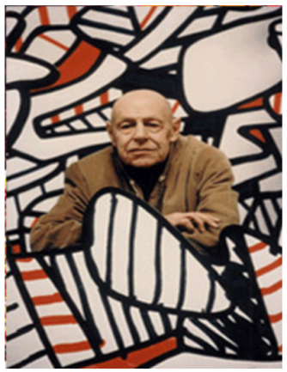
Jean Dubuffet was a famous French painter.

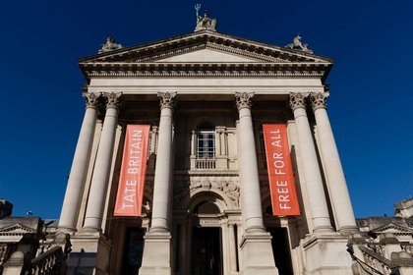
His paintings are on display in the famous gallery in London called the Tate Gallery.

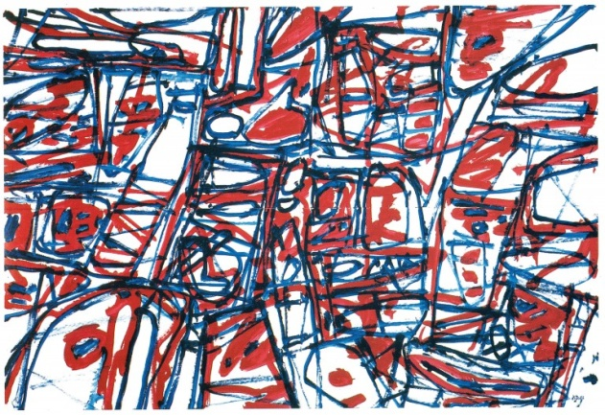
This is one of his paintings, do you like it? It looks like a scribble. It is, he drew it using a red, blue and black biro pen and scribbled while he was on the telephone. He made lots of money selling pictures like this.

You can mimic or copy his painting with pencils, crayons, paints, chalks or felt tips. Choose only red, blue and black and scribble like Jean Dubuffet.
red blue black

