**Aircrafts made during World War Two**

LI: Interpret data and use the findings to first make a tally chart and then a bar chart.

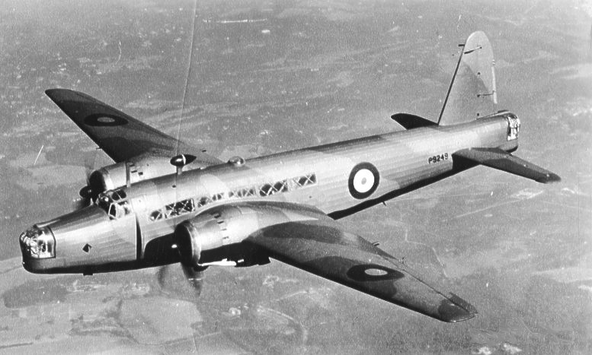[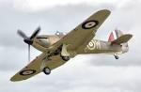](http://www.google.co.uk/imgres?imgurl=http://upload.wikimedia.org/wikipedia/commons/2/28/Hurricane_mk1_r4118_fairford_arp.jpg&imgrefurl=http://en.wikipedia.org/wiki/Hawker_Hurricane&usg=__f7ynvPJlgPKc8W46NICfxUf3ryA=&h=1501&w=2308&sz=4175&hl=en&start=11&zoom=1&tbnid=xJM8J6X5V9gLlM:&tbnh=98&tbnw=150&ei=oIGHUvnzBsfAhAeYuYGwDw&prev=/search%3Fq%3Dhurricane%2Baircraft%26safe%3Dactive%26hl%3Den-GB%26gbv%3D2%26tbm%3Disch&itbs=1&sa=X&ved=0CEAQrQMwCg)[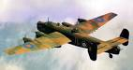](http://www.google.co.uk/imgres?imgurl=http://www.wwiivehicles.com/unitedkingdom/aircraft/bomber/handley-page-halifax-bomber/handley-page-halifax-bomber-01.png&imgrefurl=http://www.wwiivehicles.com/unitedkingdom/aircraft/bomber/handley-page-halifax.asp&usg=__ENJA1FhFvl8TXzrmC26RvP1WpMo=&h=410&w=778&sz=419&hl=en&start=3&zoom=1&tbnid=xuzZ4eUjtJhPtM:&tbnh=75&tbnw=142&ei=IoKHUvifNsKVhQeg_YAg&prev=/search%3Fq%3Dhalifax%2Baircraft%26safe%3Dactive%26hl%3Den-GB%26gbv%3D2%26tbm%3Disch&itbs=1&sa=X&ved=0CDAQrQMwAg)[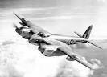](http://www.google.co.uk/imgres?imgurl=http://www.raf.mod.uk/rafbramptonwyton/rafcms/mediafiles/8476A68F_1143_EC82_2E5554EF4412C443.jpg&imgrefurl=http://www.raf.mod.uk/rafbramptonwyton/history/dehavilandmosquito.cfm&usg=__KAnYnbhCUuV_4HLKjNPga5KzZZE=&h=400&w=556&sz=13&hl=en&start=6&zoom=1&tbnid=lJj2qo_lV6-7eM:&tbnh=96&tbnw=133&ei=3oGHUqDtOo-ShQfA14GYBA&prev=/search%3Fq%3Dmosquito%2Baircraft%26safe%3Dactive%26hl%3Den-GB%26gbv%3D2%26tbm%3Disch&itbs=1&sa=X&ved=0CDYQrQMwBQ)

[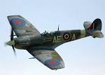](http://www.google.co.uk/imgres?imgurl=http://www.engineeringcapacity.com/__data/assets/image/0006/500991/Spitfire-crop.jpg&imgrefurl=http://www.engineeringcapacity.com/news101/sector-news/aerospace-and-defence/premier-helps-spitfire-reach-for-the-sky&usg=__BFV50A5qCmr-Wh9ftepCG7ri0Bo=&h=1017&w=1423&sz=526&hl=en&start=5&zoom=1&tbnid=rBkTjP5q_qm-VM:&tbnh=107&tbnw=150&ei=QYGHUrzuCMiShQfppoEo&prev=/search%3Fq%3Dspitfire%26safe%3Dactive%26sa%3DX%26hl%3Den-GB%26gbv%3D2%26tbm%3Disch&itbs=1&sa=X&ved=0CDQQrQMwBA)

Hurricane-16

Spitfire- 20

Wellington- 10

Halifax- 4

Mosquito- 8

Complete the tally chart below to show the results.

[](http://www.google.co.uk/imgres?q=tally+marks&hl=en&safe=off&gbv=2&biw=1280&bih=673&tbs=ic:gray&tbm=isch&tbnid=DFlC1dAJEBaPkM:&imgrefurl=http://www.talktomeblog.net/2010_12_01_archive.html&docid=ALuHsPGGhqPxLM&imgurl=http://3.bp.blogspot.com/_l3fepOGyiK4/TP7eC1BLcCI/AAAAAAAACWM/Hm5ToUHScTQ/s1600/512px-Tally_marks.svg.png&w=512&h=128&ei=MCXITqGZLIuy8QPvg9Rq&z)

Remember -

**1 2 3 4 5**

|  |  |  |
| --- | --- | --- |
| **Aircraft** | **Tally** | **Total** |
| Spitfire |  |  |
| Hurricane |  |  |
| Mosquito |  |  |
| Halifax |  |  |
| Wellington |  |  |

Make a bar chart to show your results.

**Aircrafts made during World War Two.**



20

18

16

Number of aircrafts.

14

12

10

8

6

2

Wellington

Halifax

Mosquito

Hurricane

Spitfire

4