Make a Middleton Junk Model Robot

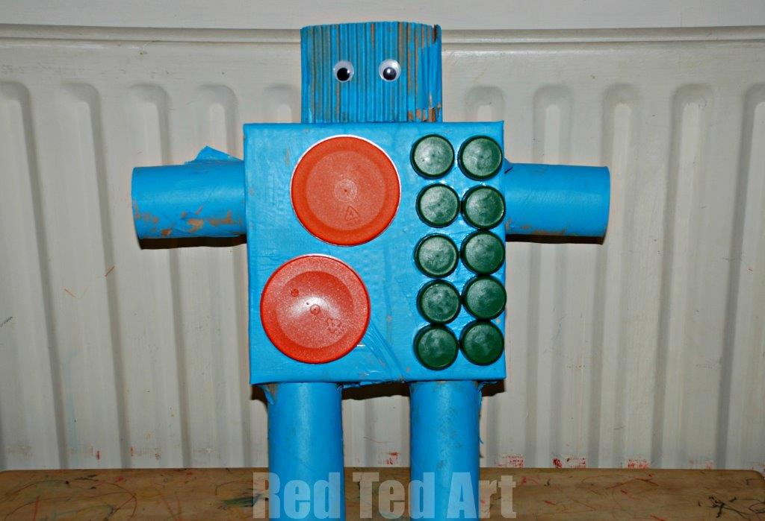

What you will need

Boxes of different sizes, cardboard, tubes, lids, bottle tops, (have a look in your recycling) sticky or masking tape, glue, paint.
Join the boxes and tubes together with the tape to make the body, arms and legs. Stick on some lids and bottle tops to look like knobs and dials. Cut out some eyes from paper and paint the robot if you want to.

