Middleton craft
YOU WILL NEED: a piece of cardboard any size, felt tips of your choice, a ruler, scissors,old magazines or stickers,glue,a pencil,a dice and sellotape.
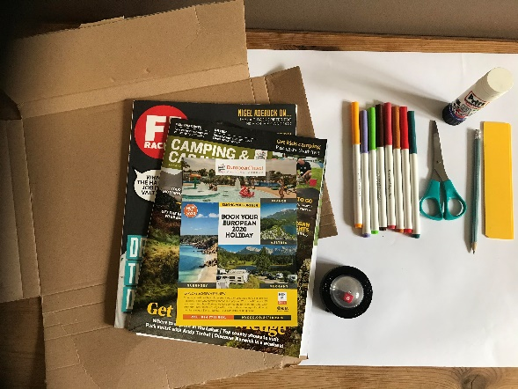
Make you’re own themed game! Mine is travel and holidays!
1)Cut out pictures from magazines to fit your theme
2)Mark out you board of the spaces

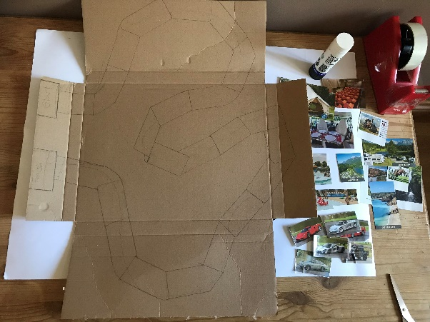

3)Stick pictures around the board and write start, finish miss turns and other obstacles for a bit of fun.
4)Decorate your board with whatever you can find at home and add your own personal touches.
5) Make your game pieces and sellotape them so that they are shiny(or laminate)
6)Start playing!

