Paper Bowl Bee Craft
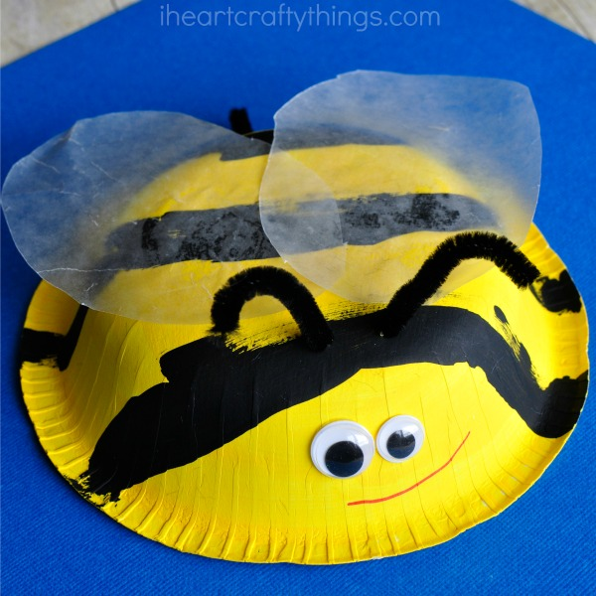
Equipment needed: small paper bowl yellow and black paint paintbrush white greaseproof paper black pipe Cleaner googly eyes red marker scissors glue

Instructions: 1) Paint the bottom of the bowl with yellow paint. After it dries, paint black stripes on to the paper bowl.
2) When the paint is dry, cut out the bee wings from the greaseproof paper (2 oval shapes). Glue them to the bottom of the bowl.
3) Cut the black pipe cleaner in half. Poke 2 small holes in to the bowl and thread the pipe cleaner through the holes to make the Bee antennae.
4) Cut off another piece of pipe cleaner and tape it to the back of the bowl for a Bee stinger.
5) Glue the googly eyes on to the Bee Craft and finish it by drawing on a smile with the red marker.

Paper Bowl Ladybird Craft
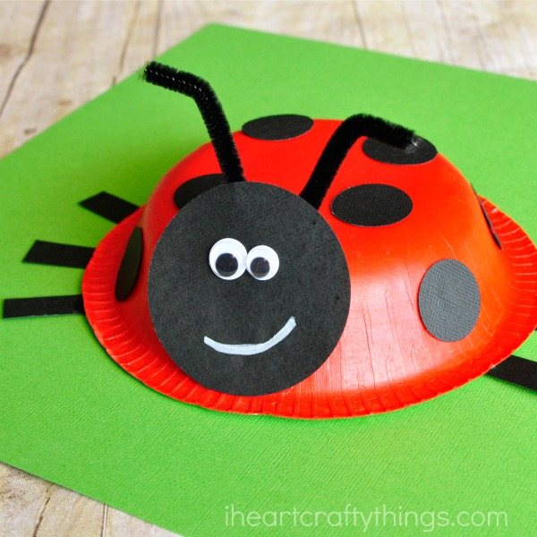
Equipment needed: small paper bowl red paint paintbrush black card black pipe cleaner googly eyes white chalk (or crayon) black permanent marker scissors glue

Instructions: 1) Start by painting the bottom of the bowl with red paint. Set it aside to dry completely.
2) While the paper bowl dries cut out a 2 and half inch black circle for the Ladybird head, several (8 - 10) 1 inch circles for the Ladybird spots and 6 Ladybird legs.
Also cut the black pipe cleaner in half.
3) When the paint is fully dry draw a line down the middle of the bowl to separate the Ladybird wings.
Glue the black spots on to the Ladybird wings and around the paper bowl.
4) Poke 2 small holes in to the bowl (where you want to put the antennae) and thread the black pipe cleaner in one hole and out of the other. Bend it together and bend the ends to make the antennae.
5) Glue the Ladybird legs under the outside rim of the bowl (3 each side). Then glue the large circle in front of the antennae for the Ladybird face.
6) Finish by gluing on the googly eyes and drawing a smile with the white chalk/crayon.

