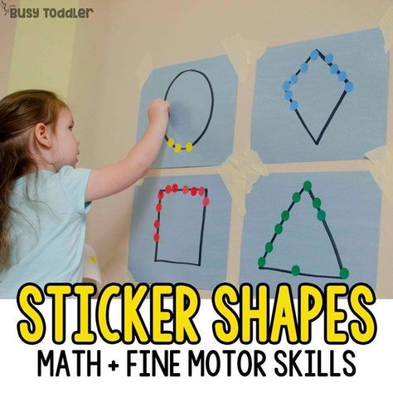
Pinterest ideas for shape:
Use shape stickers in fun ways
Hide shapes in flour, rice, water shaving foam or sand.

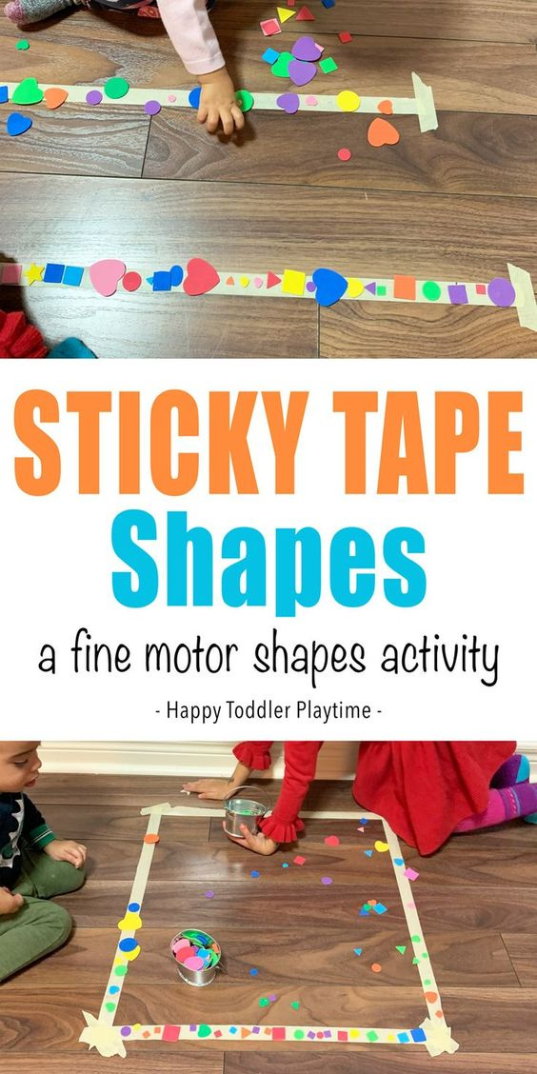

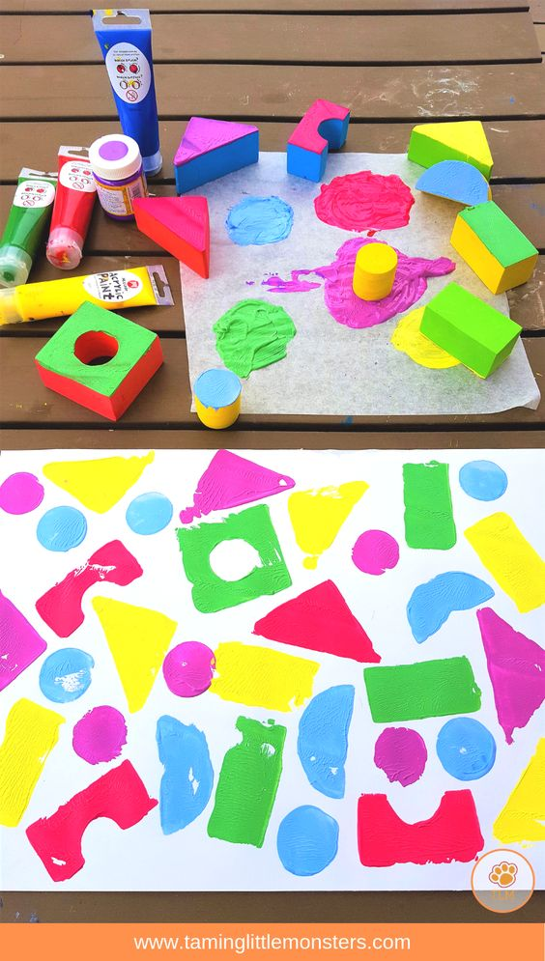
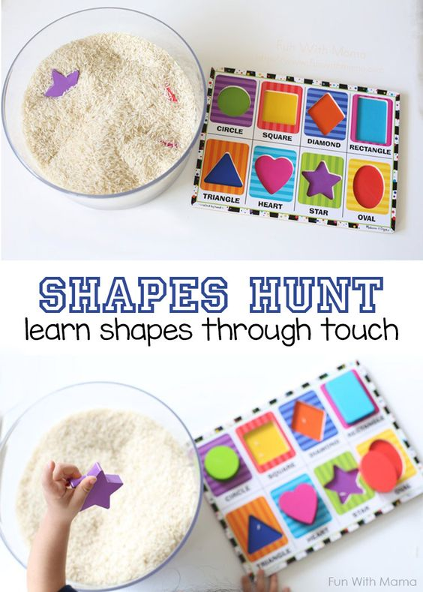
Printing shapes with sponges – if you have old sponges cut them into different shapes.

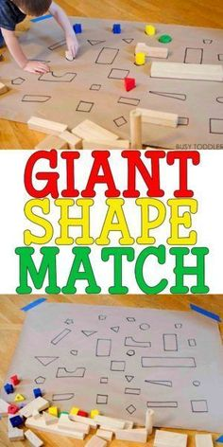
Trace round shapes on large bits of paper or any scrap cardboard. Can your child match the shape?

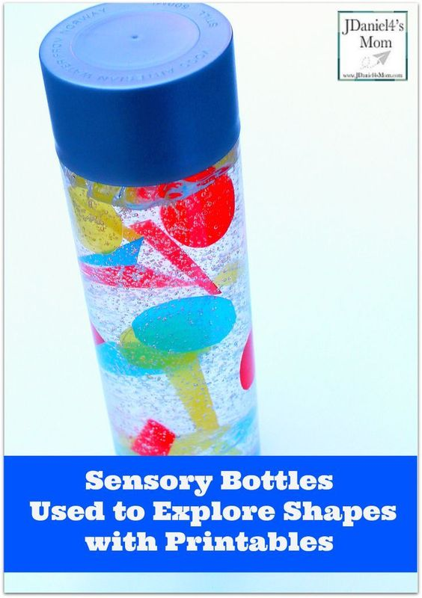
You will need to trace small shapes onto a plastic folder and cut them out.
Next, you will need to pour the hair gel into the plastic water bottle. If it looks too thick to you, you can add a little warm water.
Then you will place the plastic shapes into the bottle. You can use a chopstick to push the shapes through the gel to where you want them in the bottle.

