Summer wreath by Miss Block

You will need:

Some string, some paint or pens, some scissors, a paper plate, an egg box, glue and a grown up helper!

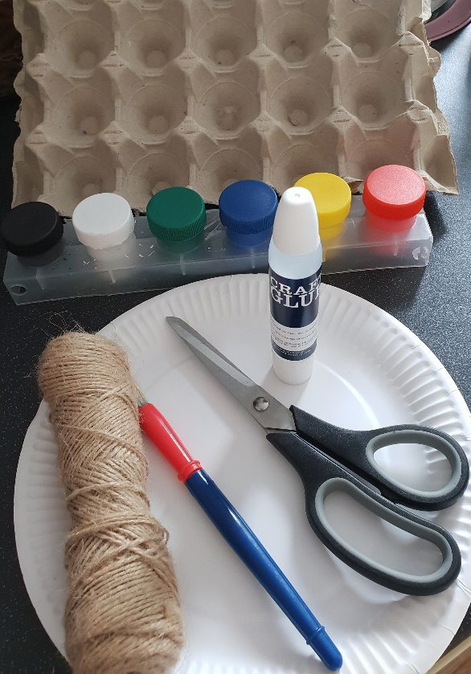

Step one.
Ask your grown up helper to cut out the middle of the plate.
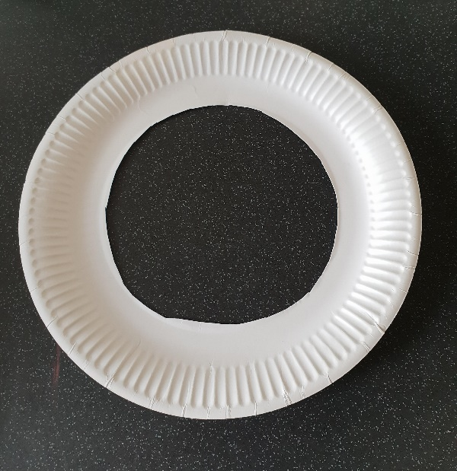

Step 2

Paint the plate whatever colours and design you want. Take your time.

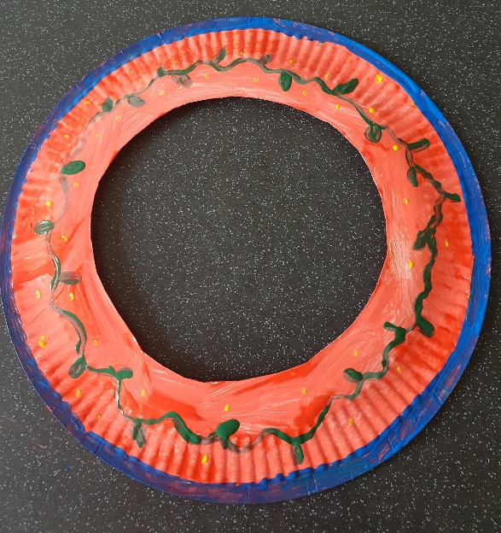

Step 3.

With help, cut out flowers from your egg box. Make as many as you like!
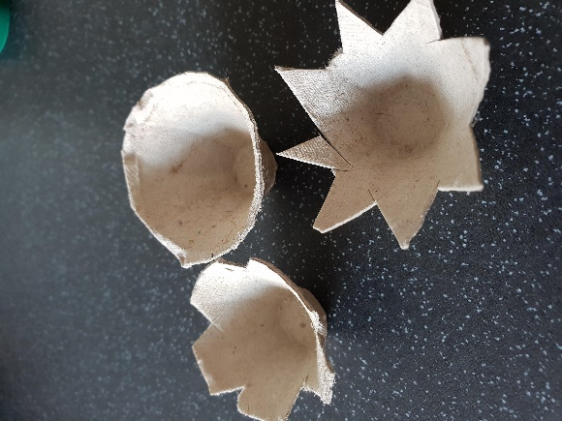

Step 4.

Paint or colour them however you would like and leave to dry.
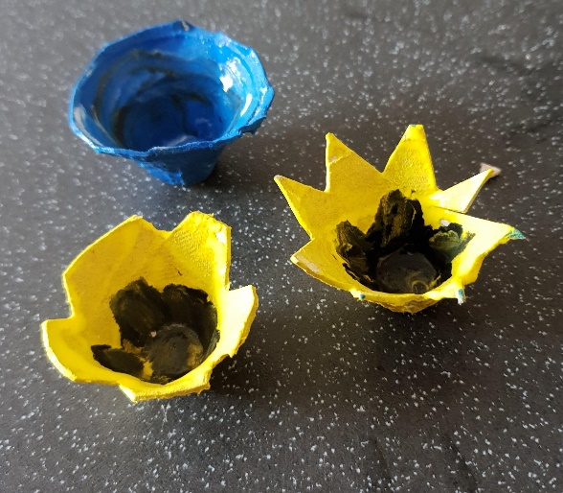
Step 5.

Stick the flowers on to the plate and leave to dry.

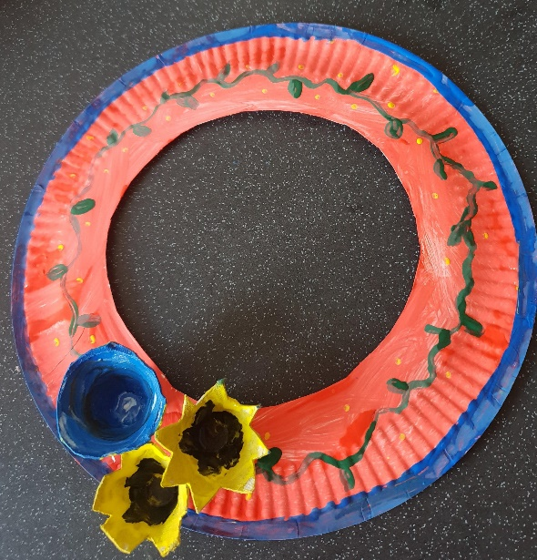

Step 6.

Ask your grown up helper to make two holes at the top and thread some string through. Tie some knots to keep it in place.

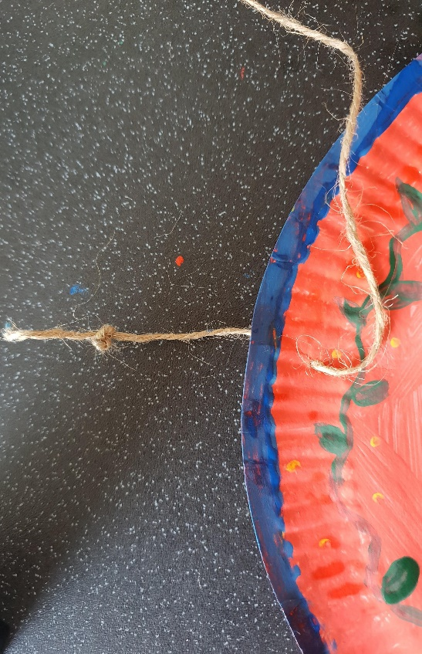

Step 7.

Now your summer wreath is ready to hang!

