The Very hungry Caterpillar

Hi to you all.
It’s Mrs ward here, some of you may know me, although i have been off for a while as i had a baby but I will be back to work once this virus is over. I am really looking forward to seeing you all and bringing my not so little baby James in to school to say hi.
This week I have been doing some arts and crafts with my son Jude so I thought I would share some ideas with you.
Jude loves reading this story so I hope you do too.
If you have the book at home then you can share that with your child. If not please find a link below so you can watch the story online.
https://www.youtube.com/watch?v=75NQK-Sm1YY

Here are some ideas of some activities you can do once you have read the story
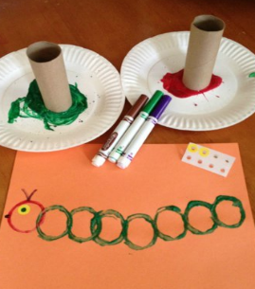
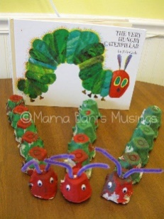
- Make a collage picture of a caterpillar by cutting lots of circles and then sticking them on a piece of paper to look like ‘The Very Hungry Caterpillar,’ or if you have an egg box and piants to make a model like the ones in the picture, or you could draw or paint a caterpillar.

Here are the pictures of what me and jude created at home, we used empty toilet rolls, paper and paint. When we had finsihed we created a butterfly using paint too.
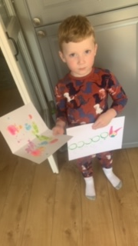
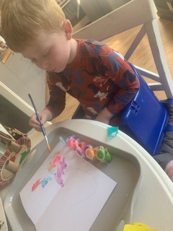
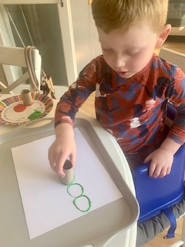

Another idea is to use empty toilet roll tubes cut into segments, colour or paint them green and red and thread onto string.
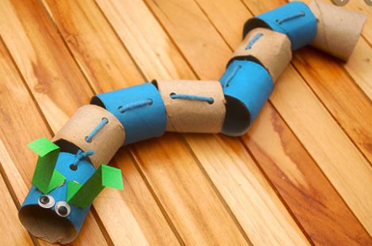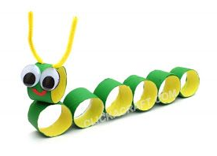

- We also watched this video on YouTube
It is interesting to see the life cycle of a real butterfly so I have shared a link to show a time-lapse video of this, https://www.youtube.com/watch?v=ocWgSgMGxOc\

- Or you could Go on a ‘Bug Hunt’, during your exercise time if you go to the park or if you have a garden look out for little creatures, you could ask your grown up to take photographs of them or you could draw them. When you go indoors you could look on the internet to see if you can find pictures and name them. You can find out different facts about them too.

- You could also have a picnic and think about all the different food the caterpillar ate in the story. You could make a fruit salad, you could use fresh or tinned fruit. Using a real knife with adult support to cut the fruit and put in a bowl.
I hope to see you all soon.

Lots of love Mrs Ward

