VE day celebration Number Problems to solve . . . . . . .
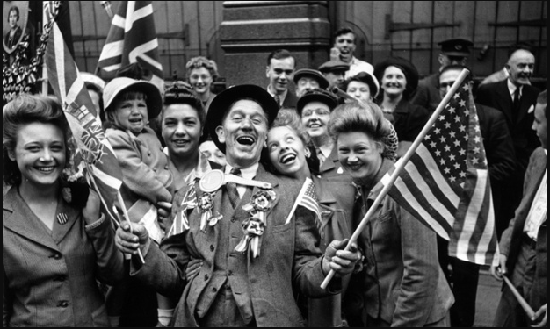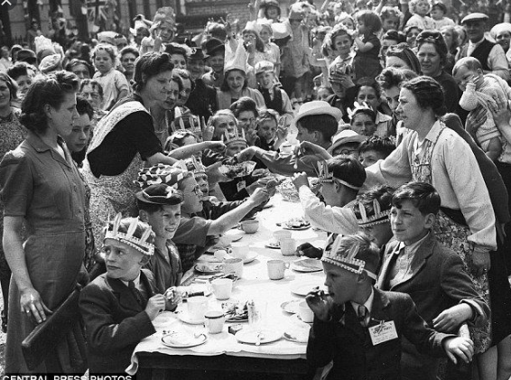
- There are 45 people coming to our street party but we only have 40 seats. How many more will we need to find?

- If my friend Tilly also comes with her Mum, dad and brother, how many people will there now be altogether?

- I am making a sandwich for every person at the party. Each sandwich needs two pieces of bread. How many slices of bread will I need altogether?

- One jug of juice is enough to give 10 people a drink. How many jugs will I need for everyone to have a drink?

- There are 30 girls, so how many boys are there?

- If ten people leave the party at six o clock, how many are still left?

- Five of these are babies. They all go for a sleep. How many are still awake?

- How many pieces of bread will you need to give your family a sandwich each?

