The majority of the following ideas were taken from https://theimaginationtree.com/40-fine-motor-skills-activities-for-kids/

I have chosen activities that may be more accessible to you at home. Ones that help develop fine motor skills but that also cover literacy and maths along the way. I have extended information on some of the more difficult activities wear you may need to make something. Other ideas are easier to understand however, if you want more information on any of the activities use the link above and click on the side headings of the activity you want, these take you to more detailed information.

Fine Motor activities
One of the most important ways we can help our children while playing with them at home or in a childcare/ classroom setting is through setting up simple activities that help to develop fine motor skills. Young children need to be able to hold and use scissors and pencils appropriately before using them in a classroom context. We cannot expect them to be able to write if they haven’t yet developed the strength needed in their hands and fingers.

There are plenty of easy ways to strengthen these muscles, practise co-ordination and develop hand: eye co-ordination using simple, everyday materials and a bit of creative fun!

There are a million variations you could make from each of these to cater for your own child’s particular interests and learning dispositions. Use these as a springboard.

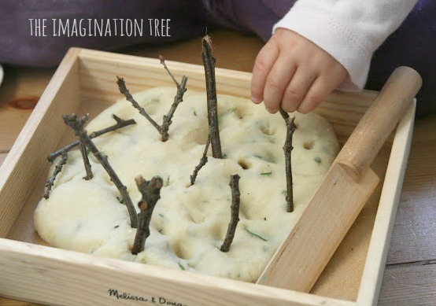

NATURAL HERBAL PLAYDOUGH
Ingredients:
- 1 cup salt
- 2 cups flour
- 1.5 cups boiling water
- 2 tbsp oil
- a few drops of fresh lemon juice (this works in the same way as cream of tartar!)
- fresh herbs eg rosemary, thyme, sage, oregano, mint (anything that smells nice and is not irritant!)
Mix all of the ingredients together in a bowl with a metal spoon. As soon as it is cool enough to touch, start kneading until it becomes soft, stretchy and pliable. Mix in the herbs. We used rosemary and lemon thyme from the garden.
Add some small twigs for pushing into the dough. It would also be lovely to introduce pebbles, grass, leaves, pine cone kernels and flower petals for adding a range of textures for exploration.
Store this in a zip-loc bag (air squeezed out first) in the cupboard. Some people suggest storing it in the fridge, but that seems to make my playdough go sticky over time. It should last up to a year at room temperature!
Learning Links:
- sensory: exploring and investigating materials/ textures using all the senses
- maths: investigating capacity / weighing/ measuring/ counting (during the cooking process)
- motor skills: fine motor development through: pinching/ squeezing/ pushing/ pincer grip/ poking/ squishing/ rolling/ rolling/ digging
- creativity: making dough represent other objects/ sculptures/ role-play/ imaginative play
- literacy: role-play language/ new vocabulary eg herb names
- phse: working independently/ sustained involvement at play

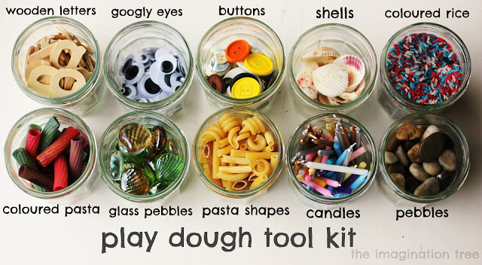
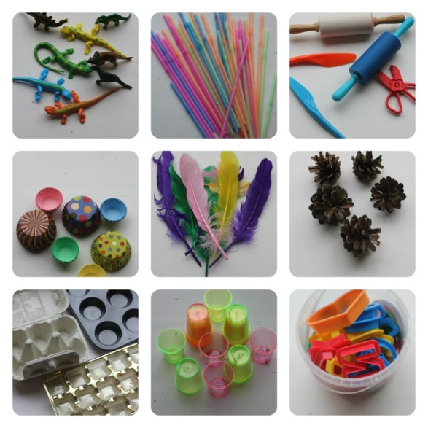
Using play dough (or in fact any type of dough) with young children is beneficial for their development in so many ways.
Here are some ideas of how fabulous it is, divided into the areas of development that it helps:

Fine motor development:
The malleable properties of play dough make it fun for investigation and exploration as well as secretly building up strength in all the tiny hand muscles and tendons, making them ready for pencil and scissor control later on.

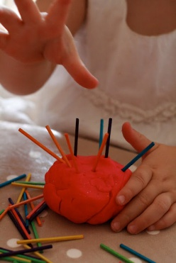
Poking in objects and pulling them out of play dough strengthens hand muscles and co-ordination
As part of simple, tactile play it can be squashed, squeezed, rolled, flattened, chopped, cut, scored, raked, punctured, poked and shredded! Each one of these different actions aids fine motor development in a different way, not to mention hand-eye co ordination and general concentration.
Having a wide range of additional extras to use while playing extends the investigation and play possibilities endlessly. Poking in sticks provides a challenge and a new physical skill.
Squeezing through a garlic press leads to wonder and amazement at seeing it change shape, as well as using a gross motor movement to accomplish it.
Sticking in spaghetti requires a delicate hand and can lead to threading and stacking pasta shapes or beads over the top.

Maths and Literacy development:
In more focused play, play dough can be used as a fantastic way to practise letter and number work. Children can form letters of the alphabet, spell out their own name, make numbers, form 2D and 3D shapes, compare lengths/ thicknesses/ weights, count out rolled balls to match numeral cards, match and sort by colour and SO many more ideas too!
Set them a challenge to roll 6 balls, add 11 sticks, form a 3D shape or even practise addition and subtraction! There are numerous ways to play and learn and after they’re finished it can be squished away for another day’s play and learning.

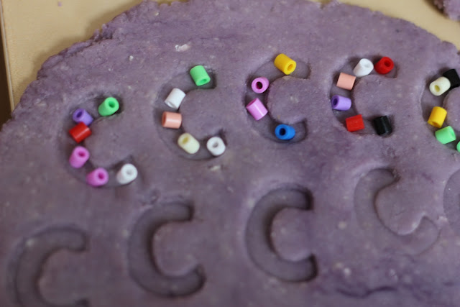
Creating letter impressions in play dough by pushing in wooden letters, then decorating with beads!

Science and Discovery:
The actual act of making the play dough together with your child can lead to lots of questioning and prediction skills. Here we have some solid materials (flour, salt etc) to which we are going to add some liquids (oil, water.) What do you think will happen? What can we make?
The child gets to explore and observe the changing state of materials in a hands-on way, and be filled with wonder as the bowl of unrelated ingredients comes together to form a sticky then smooth and squishy ball of dough! We often take these things for granted, but in the eyes and hands of a child that’s quite some transformation!
Following a recipe and instructions, counting out cups, stirring and mixing and just being able to spend time on a collaborative project with an adult are all meaningful and important experiences too!
This is by no means a comprehensive list, but all of these elements can be used to create plenty of exciting, open-ended play times:
toy creatures
straws
rolling pins, plastic knives, scissors, pizza cutters
cupcake cases in different sizes
coloured and natural feathers
pine cones, sticks, bark, leaves
muffin tins, egg cartons, chocolate boxes,
small cups and shot glasses
alphabet, number and shape cookie cutters
pasta shapes
shells
buttons
glass pebbles
toy vehicles
wooden letters and numbers
fabric, netting and ribbons
match sticks and lolly sticks

HOMEMADE EDIBLE FINGER PAINT RECIPE
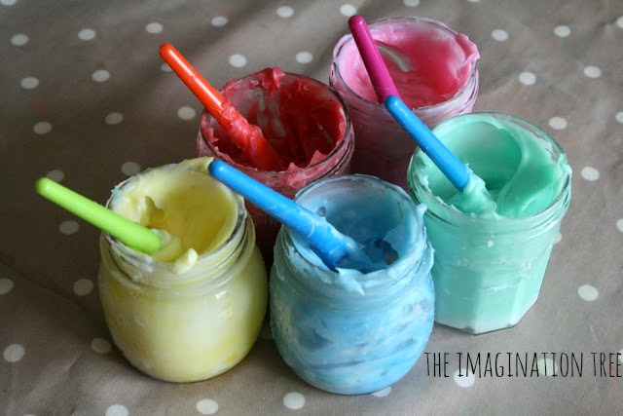
It’s totally edible (though not that delicious!) and completely non-toxic, and the best part is it was so easy to make and will last!
This is the recipe ( I googled a few, found the common denominator and went from there):
* 2 cups of corn flour (corn starch in the US I think)
* 1 cup of cold water
* 4.5 cups of boiling water
* Liquid food colouring
Method:
Mix the cornflour with the cold water and stir together. Pour in the boiling water and stir between each cup. It goes really strange (you are basically mixing a hot oobleck goop) but keep stirring and it literally seems to “melt” into a wonderful, custard-like consistency. We then separated it into individual jam jars before adding colouring, but you can do it however you like and this is the stage to add colour.
Edited to add:
Some people have found that the paint remains liquid and doesn’t thicken up as it should. I have no idea why this should be, but I have two possible solutions.
1. Try simply adding up to 1 more cup of cornflour/ cornstarch and see if that helps to thicken it.
2. Try mixing the paint in a pan on a medium heat instead of just in a bowl, as that will help to bring it together.

Other activities we have loved have included exploring sensory play materials, transporting small parts, threading beads, hands-on art projects, cutting and sticking, tearing and scrunching papers, opening and closing fastenings and countless others. Here is a selection of some of those favourites, all of which can be adapted for different age groups and abilities.
Threading with beads onto pipe cleaners Pasta necklaces
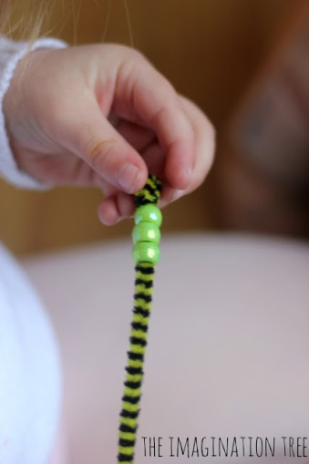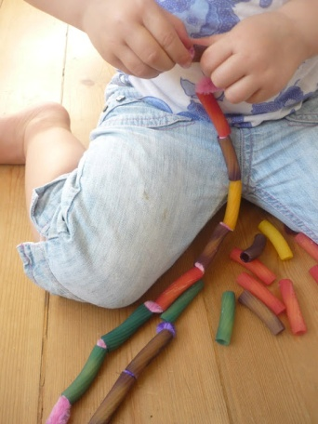
Poking straws into holes Monster play dough
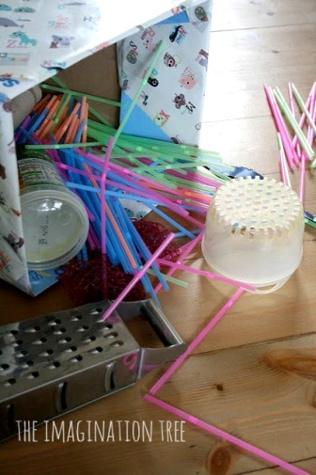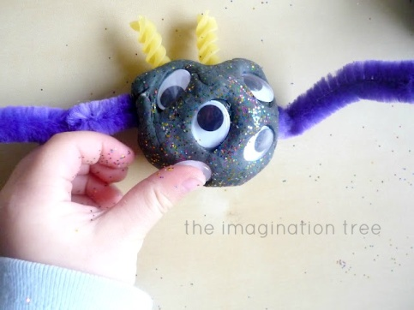
Weaving around cardboard Pipe cleaners and colanders
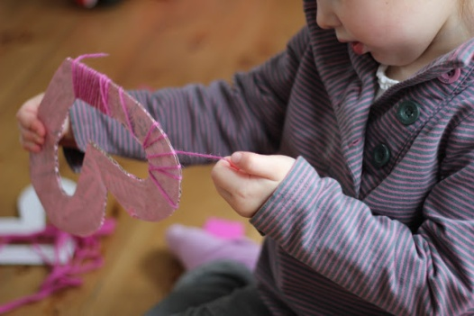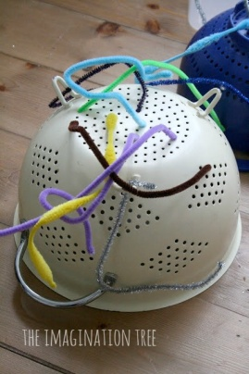

Beads on spaghetti First sewing basket
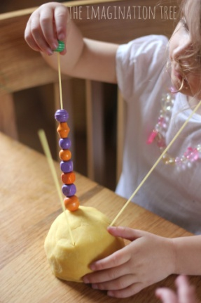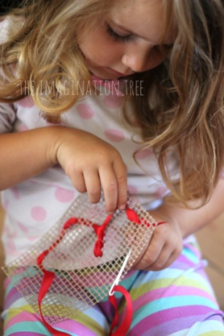
Decorating play dough eggs Sorting and pattern making with shells
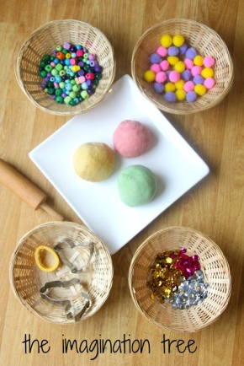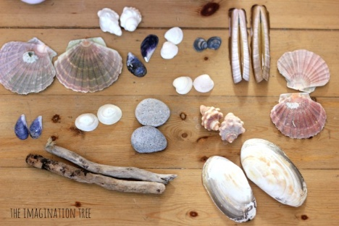
Building 3D models Patterning with lego
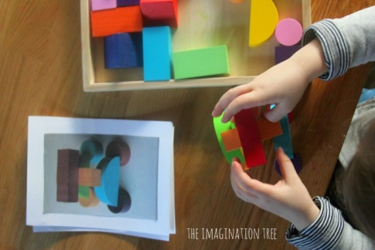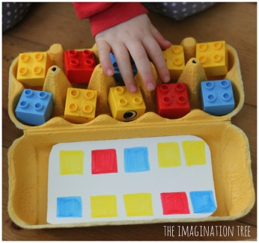
Lid posting game Stacking cups
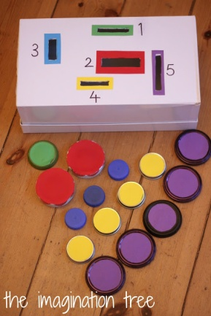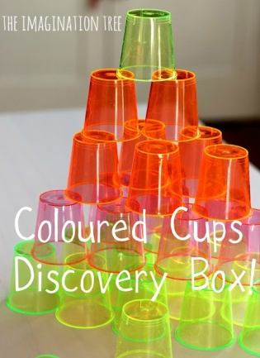

Pom pom drop game Painting with water
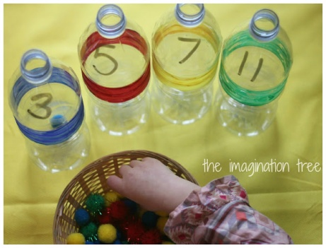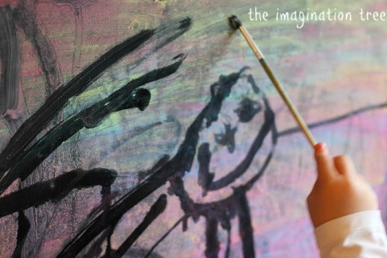
Matching lids game Painting with cotton buds
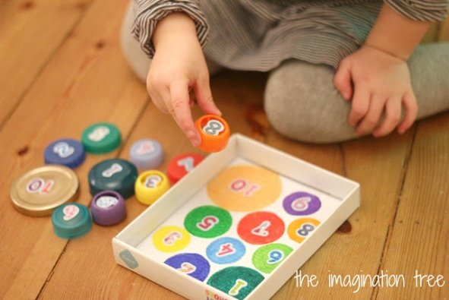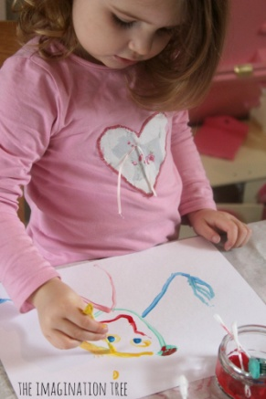
Tearing and sticking collage
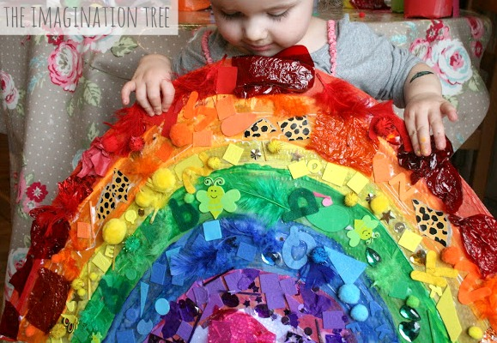
egg boxes and Peg games
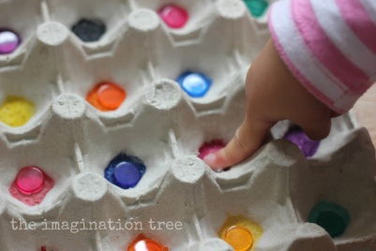
Sort- cubes, shapes, bottle tops, buttons, beads etc. Use Pegs to pick up items give 5-10 small items such as string, matchsticks, eraser, pasta, bead, teaspoon, ribbon, small toys etc Give them a timer to remove items from a container, egg box or to move items from 1 container to another. Help the children to use their middle finger and thumb to open and close the peg.
Place as many pegs around a soft toy/ dad’s/brother etc jumper/top in a given time, help peg out washing.
Tinkering with wires and loose parts in play dough
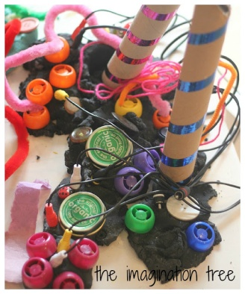
Watch the film meet the Robinsons or Charlie and the Chocolate factory talk about the inventions and machines.
Use old electrical cables, loose parts and recycled junk materials to create an imaginary play inventor’s workshop, using play dough as a base material to build and secure. This activity is fantastic for providing open-ended creative play, hands-on investigations, designing and planning, story telling and scientific discoveries! Best of all, as with all great kids activities, it doesn’t cost anything to set up. Win, win!
- Add some machine manuals and instruction booklets to provide a context of real-life literacy examples.
- Add clipboards, pencils, drawing pens, strain, rulers and protractors so they can plot out their designs properly.
Making marks in fairy dust
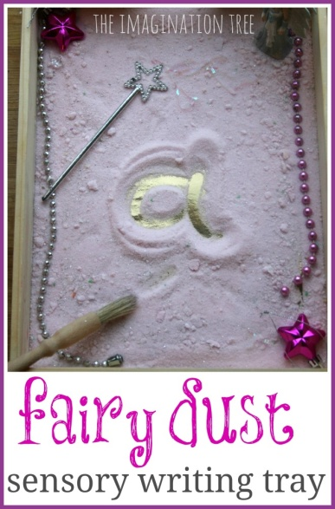
To make the fairy dust we simply added a few drops of pink liquid food colouring (add a few drops of water to it if using gel colours) to a bag of fine table salt. We shook it up and mixed the colour into the salt evenly through the bag and then tipped it out onto a baking tray to dry. A short while later we stirred through some sparkly silver glitter to add some magic to it!
We used a sparkly star ring to go onto their writing fingers as a way of marking out which one they would be writing and mark making with and to make sure they kept it consistent. This was considered a lot of extra magical fun! The fairy whispered which letters, shapes, patterns or words that she wanted to see magically appear in the dust, then they did their best to write them for her!
Play a game where the fairy called out some sounds phonetically that ....... had to write down, then read back what little CVC (consonant-vowel-consonat) word she had written. We played this in reverse too with the words being called and her sounding them out to write down herself.
When we were finished we tipped it into a storage jar for using another day.

MOON DUST SENSORY WRITING TRAY
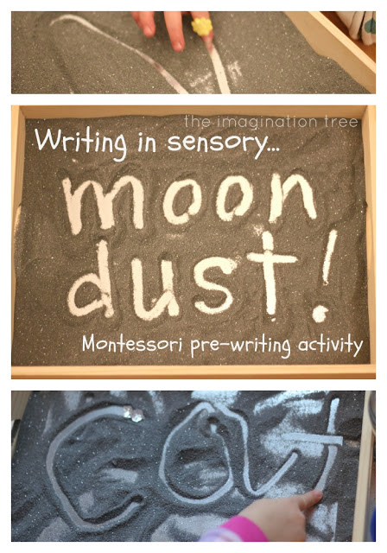
To create this we simply used one bag of economy salt, a squirt of black food colouring and a large sprinkling of silver glitter. Stir the colouring through the salt until evenly dispersed and allow it to dry before adding the glitter. It shouldn’t take too long before being ready to use!
I lined a Melissa and Doug packaging tray (how many of these do you have in your home?!) with shiny silver card, then spread a thin layer of the moon dust over the top. The dust shouldn’t be too deep or else the finger marks won’t show through to the shiny layer underneath.
If you don’t have one of those trays just pick up a disposable metallic tray at the supermarket which will have the same effect, or use any flat surface which has an edge.
For fun we stuck a sparkly yellow sticker on her writing finger to represent a whizzing comet, and she took her finger on a journey through space to land on the moon! We talked about making patterns, marks, pictures, shapes and dots and had fun making the underneath layer appear and shimmer through.

When we were finished we tipped it into a storage jar for using another day.
To build on that play time we created some new sensory salt, this time adding purple colouring, lavender essential oil and silver glitter. It truly is the most marvellous sensory material ever! So wonderfully soft and smooth, it pours so well between containers, feels lovely between your fingers (and toes!) and can be raked, drawn in, moulded, smoothed and used to create patterns and impressions.
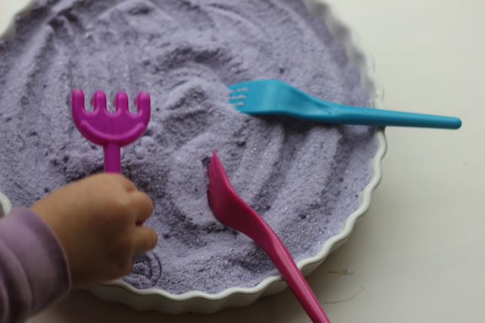

Shaving Cream Marbled Rainbows

First, spread out some foamy shaving cream on a flat surface or in a tray or pan. Smooth it out a bit.

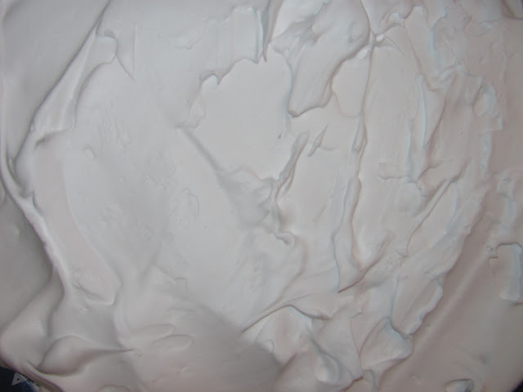
Then use either food colours or liquid watercolours and put blobs of colour with a paint brush or eye dropper. We made the colors in Rainbow order: Red, Orange, Yellow, Green, Blue, and Violet. Liquid Watercolours give the most vibrant colour!
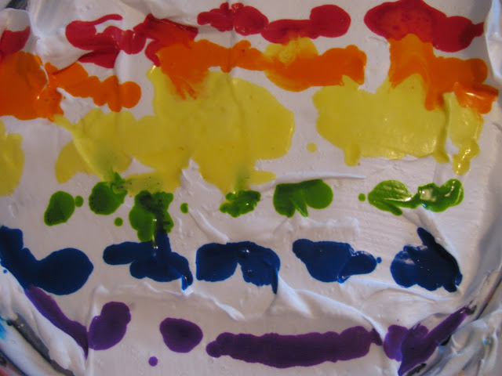
Next swirl/marble the colours with a stick. We used a kebab stick. You could use a toothpick, lolly stick, or even a stick from outdoors. If you had a fancy comb you could use that too.
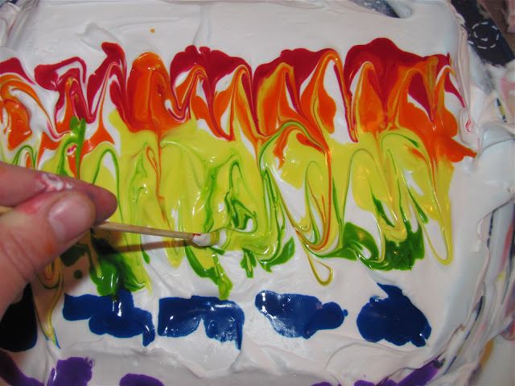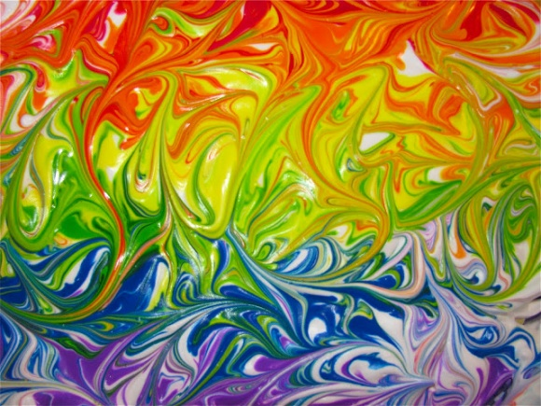

Now put a piece of paper on top of the swirled colours and press down and smooth your hands over the paper. Lift up the paper.
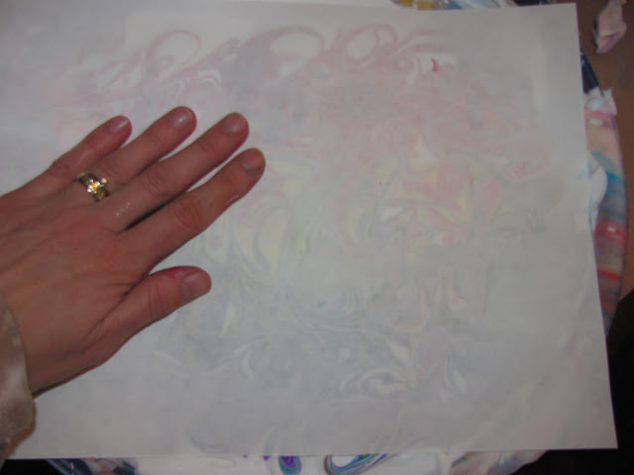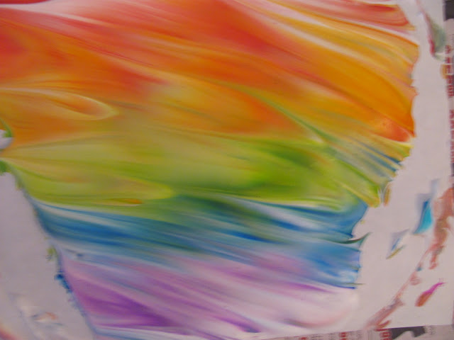

Then use a flat edge to scrape the shaving cream off the paper. You could use a lid cut in half or even a piece of cardboard with a straight edge.

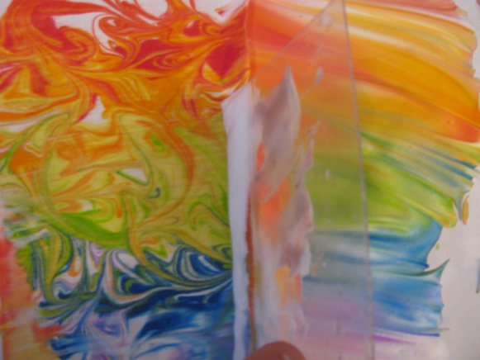
Scraping off the shaving cream reveals Gorgeous Rainbow Marbled Paper!
