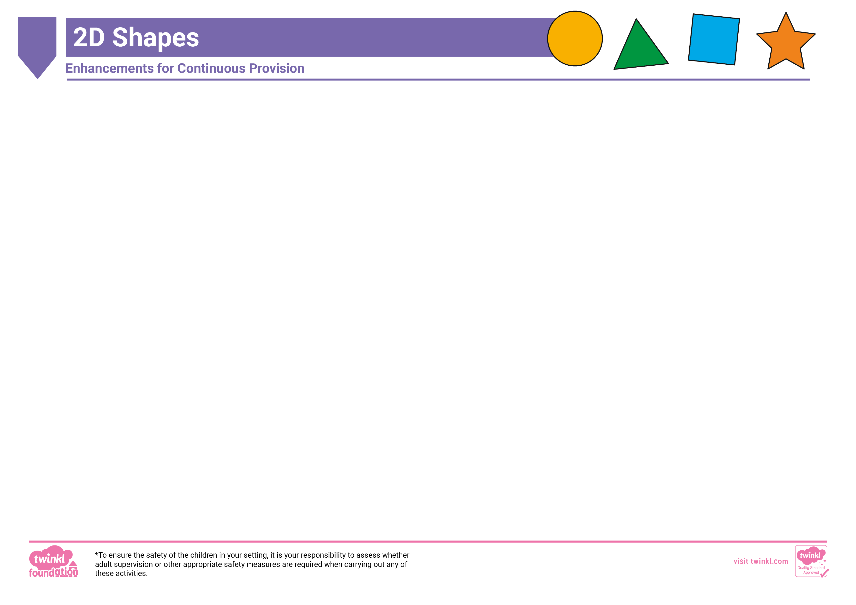
Investigation |  | Role Play |  | Gross Motor
- Add lolly sticks, matchsticks or pipe cleaners on to a tray. What 2D shapes can the children create with the materials provided?  - Wrap up a variety of 2D shapes in tissue or wrapping paper. Can the children use their sense of touch and knowledge of the properties of each shape to work out what the hidden shapes are? |  | - Set up a pizza restaurant role-play area. This lovely Pizza Parlour Role-Play Pack may come in handy. Encourage the children to create different 2D shape pizzas using playdough on baking trays. Can they create circle, square, triangle or rectangle toppings to go on the top of their shape pizzas? |  | - Add buckets of water and large paintbrushes to the outdoor area. Can the children paint different 2D shapes on the floor?  - Add large chalks to the outdoor area. Challenge the children to create shape pictures by just drawing 2D shapes. Can they draw a shape rocket, a shape house or a shape castle?
Reading |  | Malleable |  | Music
- Cut out 2D shapes from different coloured paper and write one letter on each shape. For example, s, a, t, p, i, n. Encourage the children to make a word using the shapes and ask their partner to read it.  - Add shape books to your reading area for the children to explore and discuss together. |  | - Add some 2D shape biscuit cutters to the playdough and ask the children to create shape biscuits.  - Print these 2D Shapes A5 Cut-Outs and stick them on to card. Can the children create shape prints with them in the playdough? Can they create a shape picture with the shape prints? |  | - Add these fun 2D Shapes and Rhymes to your music area.  - Create shape shakers by filling bottles with different materials. Stick a different 2D shape on each shaker. Encourage the children to work with a friend. Their friend names a shape and they play the shaker with that shape on it.
Water |  | Sand |  | Maths
- Place 2D foam shapes into the water tray and add sieves. Can the children catch a shape and say what the shape they have caught is called? You may also like to add bowls next to the water tray for the children to sort the different shapes into.  - Add a variety of 2D shape objects into the water tray for the children to find, such as circular and square buttons, triangle sequins, an old disk and a ruler. |  | - Add water to the sand to make it damp and add 2D shapes. Can the children make prints using the 2D shapes? Can they name each shape?  - Place small treasure chests into the sand and place one shape in each chest. The children need to find the buried treasure, close their eyes and feel the shape inside. Can they guess what the shape is? |  | - Place these super 2D Shapes Peg Board Challenge Cards next to your peg boards to inspire the children to create 2D shapes.  - Add these 2D Shape Activity Pictures to your maths area to encourage the children to create pictures using 2D shapes.  - Place 2D shapes into different feely bags. Can the children work out the shape without looking at it? Can they describe the shape to a friend for them to guess what it is?
Construction |  | Mark Making/Fine Motor |  | ICT
- Provide the children with pieces of string of different lengths. Can they make a 2D shape, such as a rectangle, with the pieces of string and then fill the shape with building bricks/foam bricks?  - Can the children find the matching pieces of these 2D Shapes Connecting Bricks and connect them together? A fun way to explore the properties that make up different 2D shapes.  - Place tape on the floor to create different 2D shapes. Can the children place blocks on to the tape and work out the shapes? |  | - Add 2D shapes to the mark-making area. Can the children draw around the shapes to make different shape pictures?  - Encourage fine motor skill development and a greater understanding of the properties of 2D shapes with these Geoboard 2D Shapes Challenge Cards.  - Place 2D shapes or 2D shape cut-outs into a tray. Can the children use tweezers to cover each shape with sequins? |  | - Load this Everyday 2D Shapes PowerPoint on to your interactive whiteboard. Challenge the children to click on the shape, see the everyday objects that are revealed and then, find other objects in the classroom that are also that shape. How many different objects can they find?  - Provide the children with a digital camera or tablet to take around the classroom. How many different 2D shapes can they find and photograph?
Workshop |  | Sensory/Messy |  | Painting
- Encourage the children to create their own 2D shape transient art. Draw large 2D shape outlines using chalk in an activity tray and add a selection of resources, such as, ribbons, bottle tops, buttons, pom-poms, pipe cleaners, foam shapes and glass pebbles.  - Provide the children with coloured paper, scissors and glue. Can they create their very own 2D shape pictures? |  | - Stick these 2D Shapes Story Stones on to a selection of stones and then hide them in a tray filled with coloured rice. What shapes can the children find?  - Place a selection of 2D shapes on to a lightbox for the children to explore. If you cover half of the shape up, can the children still work out what shape it is? |  | - Cut out potatoes in different 2D shapes so the children can paint and then print with the potatoes. Can they name the shapes as they print them?  - Challenge the children to paint shape pictures using different tools, such as cotton buds or sticks dipped in paint. Can they paint a shape car? Can they paint a shape cat?
We have a pack version of this plan that also contains all relevant resources and can be downloaded here.

