Energy – Wind Power Fact Sheet
What is wind?
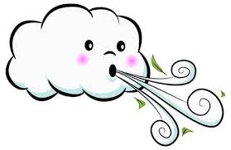
Wind is a current of air moving across the ground.
It is a source of energy and can make things move as it pushes on them.
We can feel this push when we are outside on a windy day.

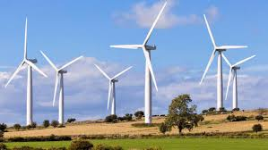
We make use of wind as a source of energy in windmills and in wind turbines.
In a wind turbine, the blades are blown round by the wind and their movement is converted into electricity by a generator.
A group of wind turbines is called a wind farm.
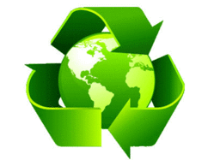
Wind power is an alternative energy source.
It is good for the environment.
This means that the power of the wind can be used in place of other energy sources such as coal, oil, and nuclear reactions.
Wind can be used to produce electricity that heats homes and lights streets and buildings.
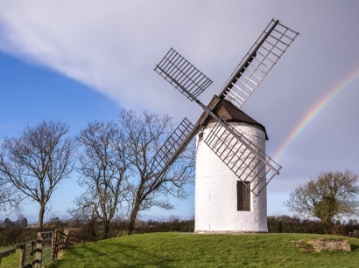
Wind turbines used to be called windmills.
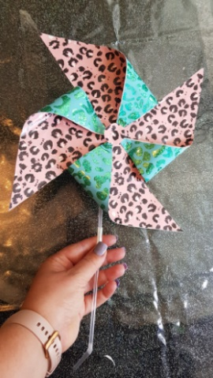
The earliest-known windmills were built more than 1,000 years ago.
People used them to grind grain.

Look for the video to make your own windmill on the school YouTube channel, you can also the template on the home learning page.

Useful Links
- CBeebies - Do You Know Wind Turbines https://www.youtube.com/watch?v=RXHko5OyQts
- Kids Academy- What is Energy? Types of Energy https://youtu.be/4HdxQhBRDUI
- Science for kids - Learn About Wind Farms Caitie’s Classroom https://youtu.be/U5_cZ3IRUkU

