Floating and Sinking
Here is a floating and sinking activity that can be done with any container preferably a clear container, but a washing up bowl will do just the same.
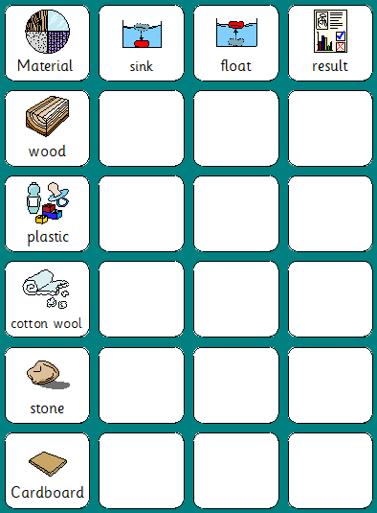

Can you make a prediction for each of the materials? Whether you think they will float for sink. You can cut out these symbols to place on the chart.
Then record the result and see if you were correct.

Extension can you see if you can find 2 more objects around your house that float and sink.

Can you draw a picture of the objects to show what happened during your experiment?

