Make a Balloon Hovercraft

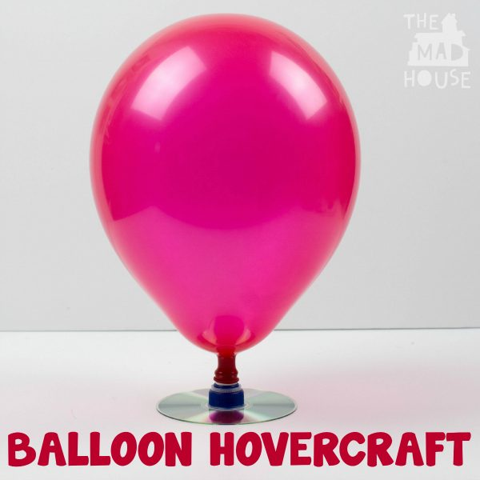

What you will need
- A CD
- Strong glue (Bostick or Uhu)
- A balloon
- A sports water bottle cap

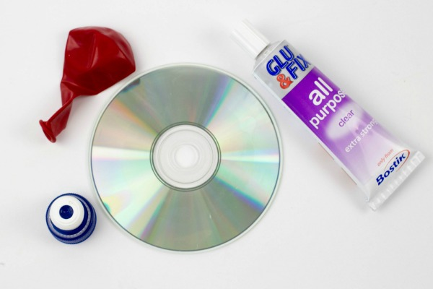
What to do
To start, glue the cap over the hole on the CD using strong glue and let it dry.
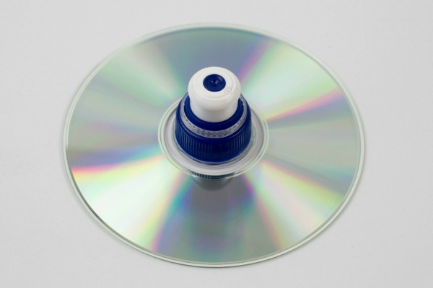
Blow up your balloon and then making sure the bottle top is pushed down, place it over the cap.

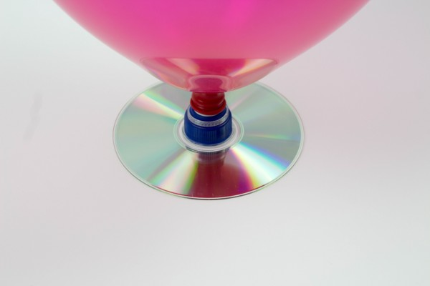
Put your hovercraft on a flat surface .Pull the water bottle top up and gently push your hovercraft around.

How does this work?

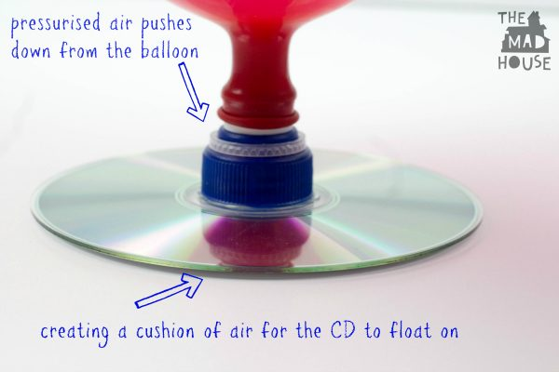

You can’t see it but the air from inside the balloon pushes down through the bottle top. This gives the CD air to float on and move around like a hovercraft.
Have fun with your hovercraft from Mrs Graves!

