Making a Non-Newtonian Fluid – Is it solid or liquid?

Also called ‘oobleck’ after a Dr Seuss book, this mixture of cornstarch and water is very unusual because it behaves like a solid and a liquid. Have a look at this video for some more information: https://www.youtube.com/watch?v=biAOOJgvRYI

It is easy to make and fun to play with!

Basic ratio
2 parts cornstarch to 1 Part water

Ingredients
- 2 Cups Cornstarch
- 1 Cup Water
- Food colouring (optional)

Instructions
- Step One: Pour 2 cups cornstarch into a bowl
- Step Two: Add 1 cup of water and stir to combine
- Step Three: If adding food colouring to your oobleck do it at the mixing stage
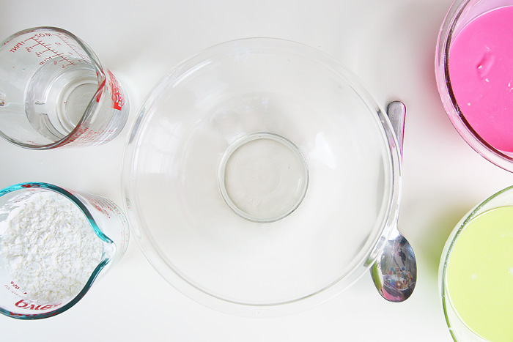

Time to play!
Take a handful of the mixture. When you squeeze your oobleck it will behave like a solid and you can shape it into a ball.
When you release it, the mixture will run through your fingers like a liquid.
- What happens when you pour it?
- What happens when you jab it with you finger?
- Can you make your oobleck dance? (have a look at the video below)
https://www.youtube.com/watch?v=SYMvOxIsES4
Take some photos if you can, we would love to see your investigations!

