Organs of the human body
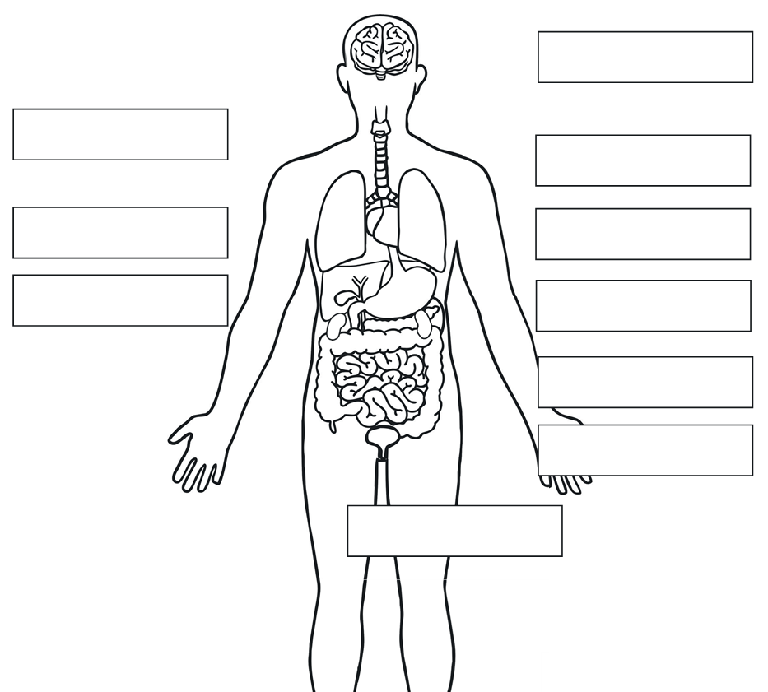
Can you label the organs of the body using the words below?

kidneys
bladder
lungs
brain
heart
liver
stomach
trachea
Small intestine
Large intestine

