PLANTS
Plants are a living thing. Like all living things, they need a few things to help them grow. For example, light, air, water, nutrients, a space to grow and optimal temperature.
Activity:
With the help of an adult, cut out the pictures below and place them in the correct order.
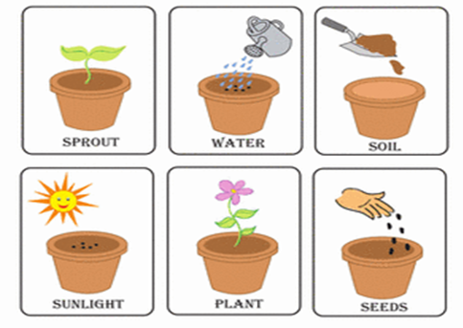
Optional Activity: Over the next few weeks, can you take photos of any plants or flowers you see in your garden or whilst you are out and about . Maybe you can tell us (or send a picture) of how you are helping look after the plants/flowers in your garden and what you think they need to help them grow. Photos can be sent to:admin@middleton.herts.sch.uk

