People I meet . . . . . . . . .
When I am out for a walk with my family I will look for the following people;

A person walking a dog 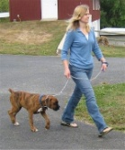
A police officer 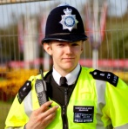
A person pushing a pram 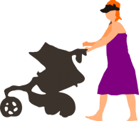

A friend that I know
Someone wearing a hat

A person on a bike 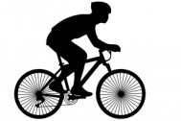

Someone carrying shopping 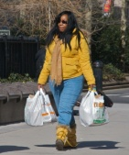

I also saw . . . . . .. . .

