SHOPPING
Lets have some fun baking some ROCK CAKES
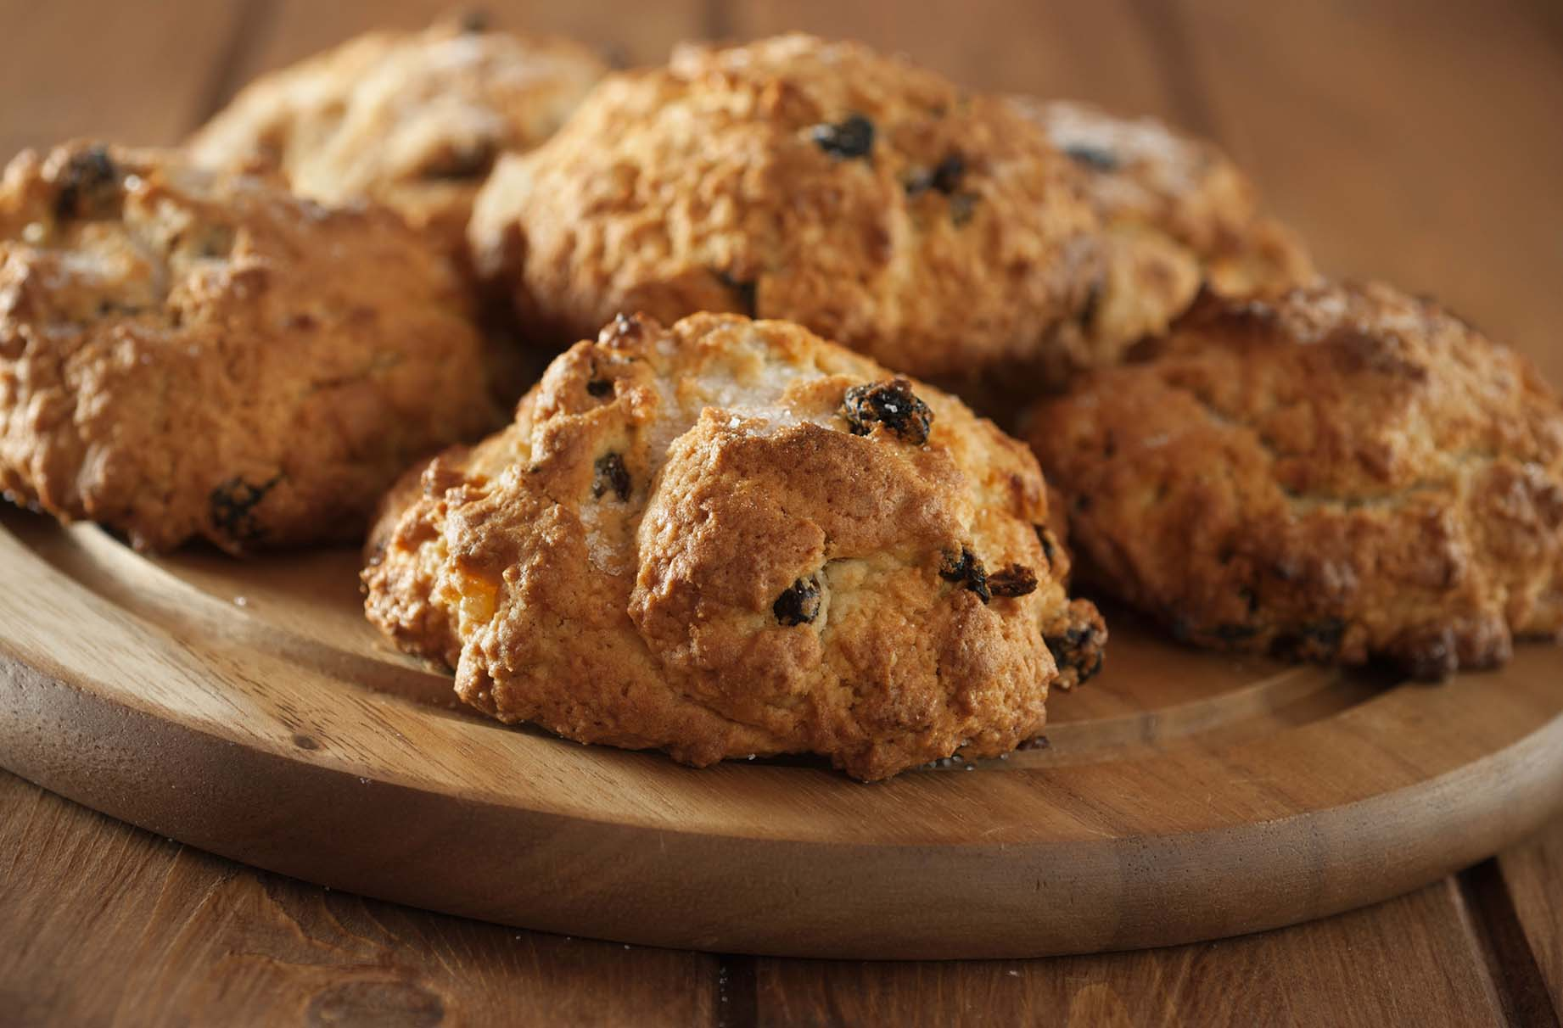

When you next go out shopping with an adult, see if you can find these items and tick them off your list. If you are not able to get out and about at the moment, don’t worry you can ask an adult to help you check in your home for these items instead.
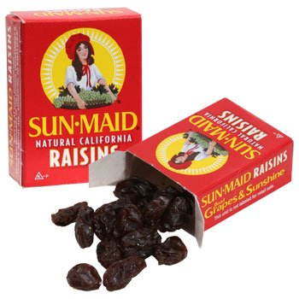
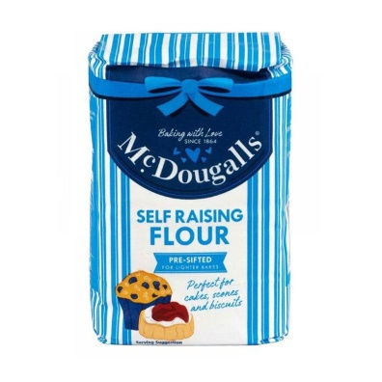

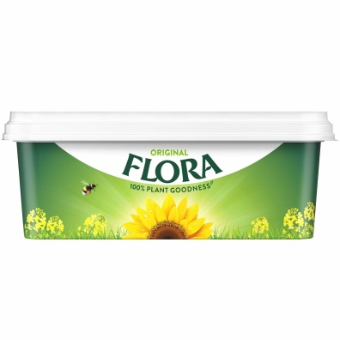

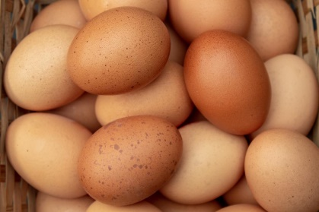
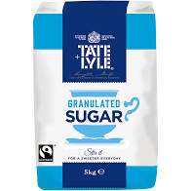
Ingredients to make your Rock Cakes:
250 grams S.R Flour
100 grams margarine
50 grams sugar
100 grams dried fruit
1 an egg
1 tbs milk
1 tbs sugar to sprinkle on top

Method:
Rub flour and margarine together until you have made fine breadcrumbs.
Mix in fruit and sugar.
Add egg and milk and blend together to make a stiff mixture.
Add more milk if necessary.
Shape into 8 round balls and place onto a greased baking tray
Bake for 20 mins at 180c
Ask your adult helper to remove the tray from the oven and allow the cakes to cool before eating

Enjoy!

