The Nature World

Hi all at Middleton.
I wanted to share an idea I have been doing with Jude at home. We have been enjoying going on walks to different parts of a forest to complete a nature hunt
You can print different nature hunt lists from the internet, here are some ideas
https://www.google.co.uk/search?q=nature+hunt&source=lnms&tbm=isch&sa=X&ved=2ahUKEwji38uN247qAhV1sXEKHUctCd8Q_AUoAXoECA0QAw&biw=1229&bih=601
Or you can also create your own. We have done both and had lots of fun with them.

All you need
- Paper
- Pens
- And lots of ideas

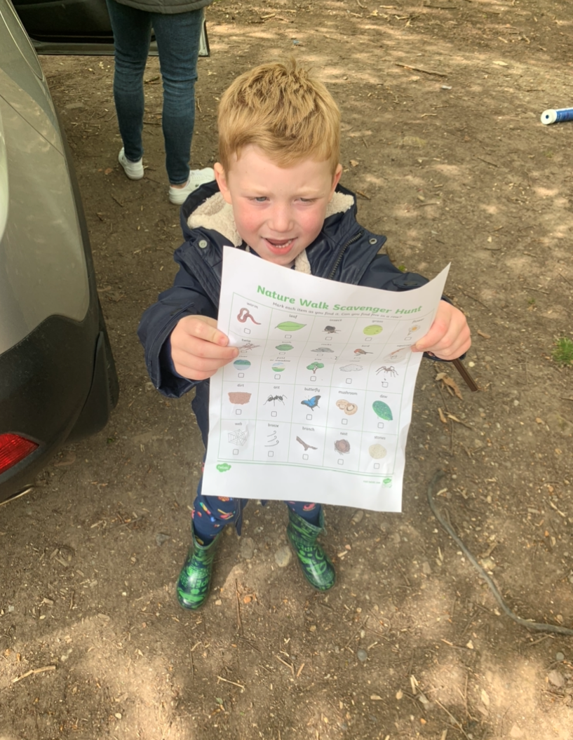
Here is Jude with a nature hunt we made ourselves and one we printed from the internet

You can make your own nature hunt list for your Garden/forest walk/or walk around near your house. Or you could make up your own one

Forest walk ideas to look for -
- Butterflies
- Flowers
- Tress
- Birds
- Horses
- Ponds/lakes
Garden ideas to look for -
- Grass
- Birds
- Flowers
- Tress
- bugs
Walk near your house ideas for you to look for-
- Cars
- Trees
- People
- Traffic lights
- Flowers
- Buses

Can’t wait to see some pictures of all your nature walks.

Mrs Ward

