PELICAN CROSSING SIGNALS
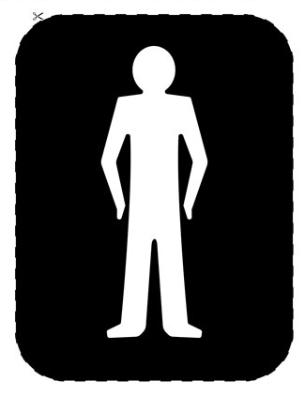
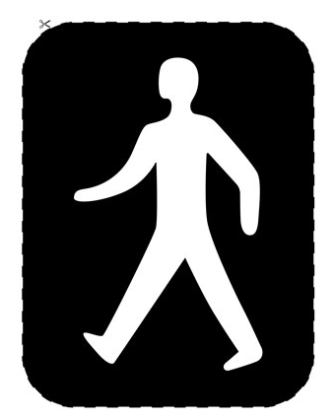
Colour the man the correct colour – you will need red and green pens or pencils
Go
Safe to cross

Stop
Do not cross

