What do I need?

This is a quiz, you will need:
- A highlighter pen.
- An adult to help you with the reading.
Read the sentence describing the animal. Then read the three choices and decide which one the animal needs to help it. Highlight your choice.
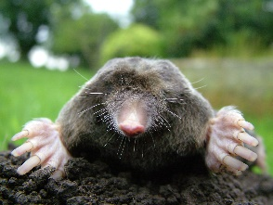
Example
“I live underground and dig tunnels.” I need…
- Feathers
- Strong paws and long claws
- Stripy fur

Now it is your turn
1 “The leaves that I eat are at the top of a tree.”
I need….
- Large ears
- A strong tail
- A long neck

2 “I travel in the desert.”
I need….
- To store water
- To eat fish
- To grip on ice

3 “I swing from tree to tree in the jungle.”
I need….
- A large nose and nostrils
- Strong hands, feet and tail
- Webbed feet and scales

4 “I live in the arctic on land and sea.”
I need….
- A long tongue
- Small hooves
- Thick, waterproof fur

5 “I can drive, watch a film and look for rainbows.”
I need….
- Good eyesight
- Wings
- Furry feet

6 “I enjoy learning and playing.”
I need….
- Long hair
- A Middleton uniform
- Curly tail

On the next page are some pictures of the animals, can you draw a line from the animal to the number of the sentence that matches it.

1 2 3 4 5 6

