Looking at Birds

Look out of your window, can you see any of these birds? You have to look quickly and keep very still because they fly away very fast!

A Robin

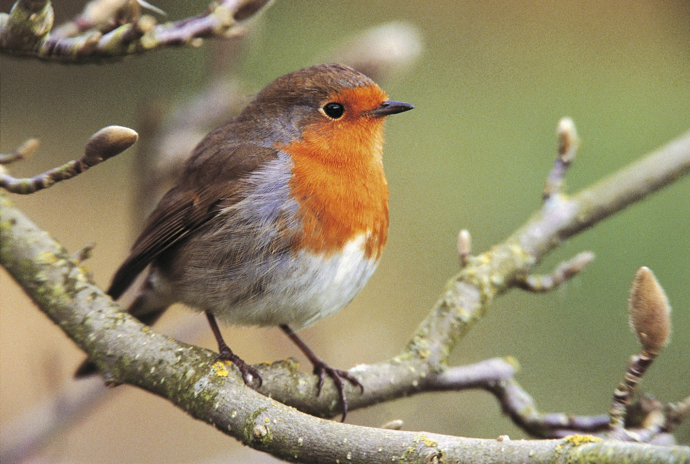

Here is a robin. He has a red front and tiny black eyes. If you are digging in the garden he will hop around near you looking for worms to eat. He likes to sing all day long.

Blue Tits

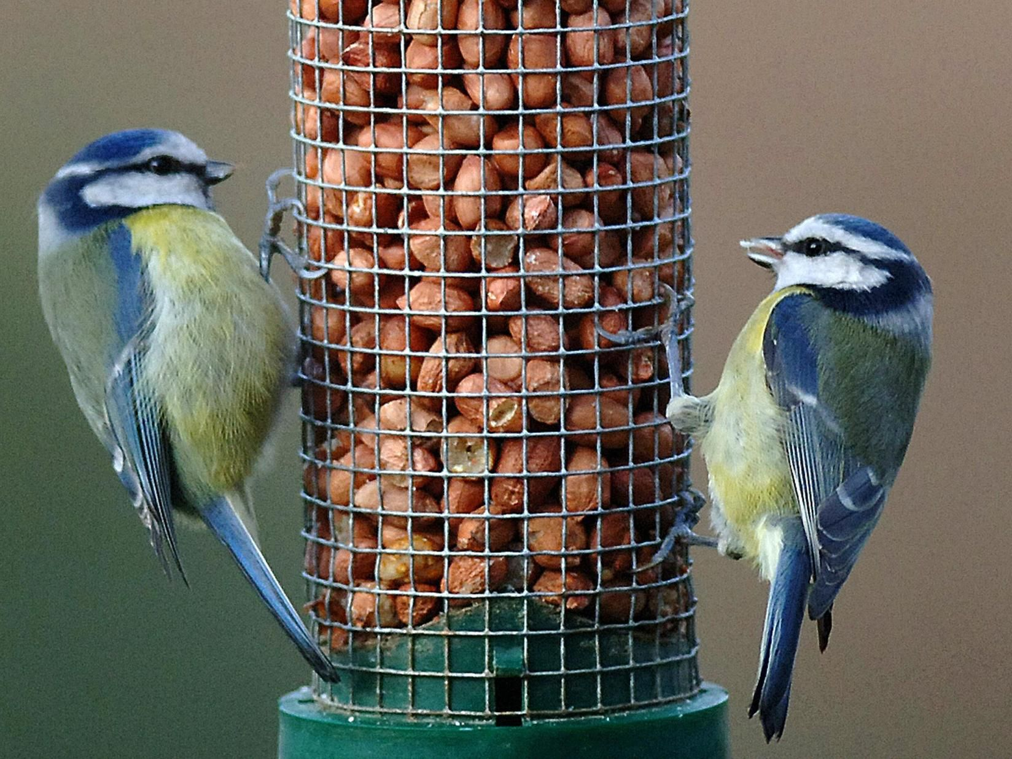

Here are some blue tits eating peanuts from the bird feeder. They are yellow, blue and green. Aren’t they pretty! They like to fly around with a friend and don’t feel safe on the ground.

A Black Bird

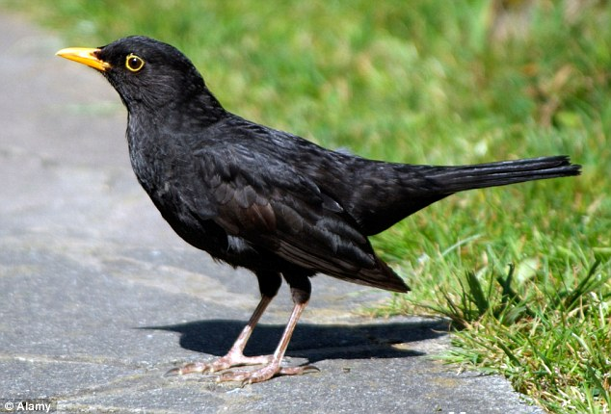

This is a blackbird and you will see them hopping about on the grass and pulling up worms to eat. The boy blackbird has black feathers and the girl has brown with an orange beak. They are a bit cheeky!

A Sparrow

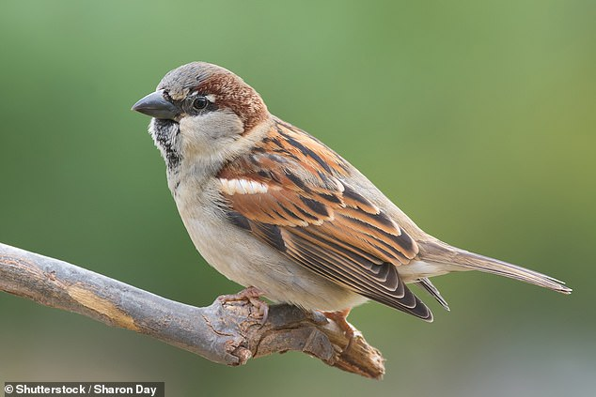

There are lots of sparrows hopping around in the garden. In the spring they pick up twigs, moss and feathers in their beaks to make a nest to lay their eggs. They can be very noisy little birds.

Enjoy looking at the birds, which one do you like best? I really like the robin!
Love from Mrs Graves.

