Hello, it’s Mrs Morgan here. I hope you enjoy this activity and use all your senses.

Sensory Inspiration
Use the senses to engage with the outdoors and stimulate language and imagination

Equipment:
Cut up paint sample cards or coloured paper strips, egg box, plastic pots

Activity:
1. Sight – Rainbow chips. Prepare a range of different coloured tokens (paint sample cards work well). Provide your child with a different coloured token/paper strip and challenge them to find a match in nature e.g. flower, leaf, stone etc. Discuss which colours were easiest/hardest to match and why.

2. Touch – Touchy feely egg boxes. Provide your child with an egg box and challenge them to find 6 materials that all feel different to place in each compartment. What words could you use to describe how each object feels?

3. Hearing – A handful of sounds. Sit quietly outside with one hand open. Each time you hear a sound you can close one finger over your palm hence capturing the sound there. Ask your child to release a sound by lifting a finger and describing what they heard.

4. Smell – Perfume creation. Provide your child with a pot of water, flower petals, leaves etc and a stick (for mixing) and challenge them to create a perfume. They can give the perfume an imaginative name and even create an advert.

5. Taste – Fruit and vegetable recipes. If you have fruit or vegetables growing in your garden, think of a recipe you could use to make a tasty treat. ALWAYS ASK AN ADULT BEFORE YOU EAT ANYTHING GROWING IN THE GARDEN.

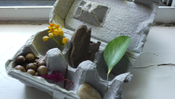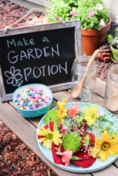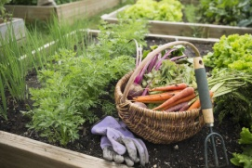

Learning opportunity
In preparation for these activities, discuss how humans use their different senses – do we rely upon some senses more than others? How does this differ from other species? e.g. Bats use echolocation which relies upon hearing. Eagles have excellent eyesight and badgers depend upon their sense of smell.

