This resource is intended to be used if making a visit to a relative or a friend, maybe for the first time since lockdown.
Explore the questions with your child prior to the visit and afterwards. You can scribe for your child or, if they are able, they may like to record their answers themselves.
I have added some symbols which you may like to cut up and place in front of the child to assist them in their communication.
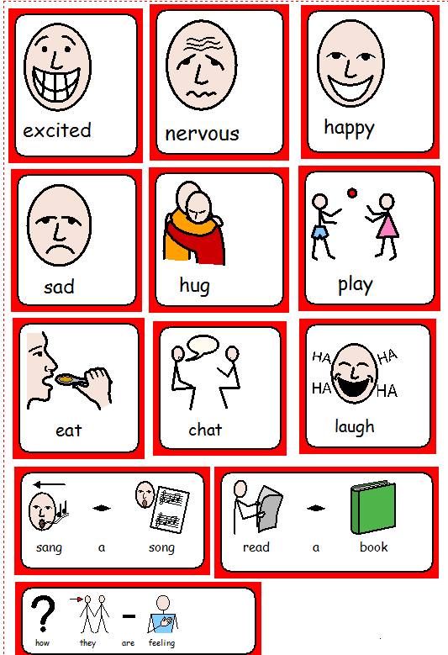

Today I am visiting

I feel when I think about visiting

I last saw them . . . . . .

I will ask them . . . . . . . .

I want to . . . . . .

My favourite part of the visit was . . . . .

While I was visiting we . . . . .

I felt . . . . .

I would also like to visit . . .

