Healthy Living Ideas

Go for A Walk In The Woods

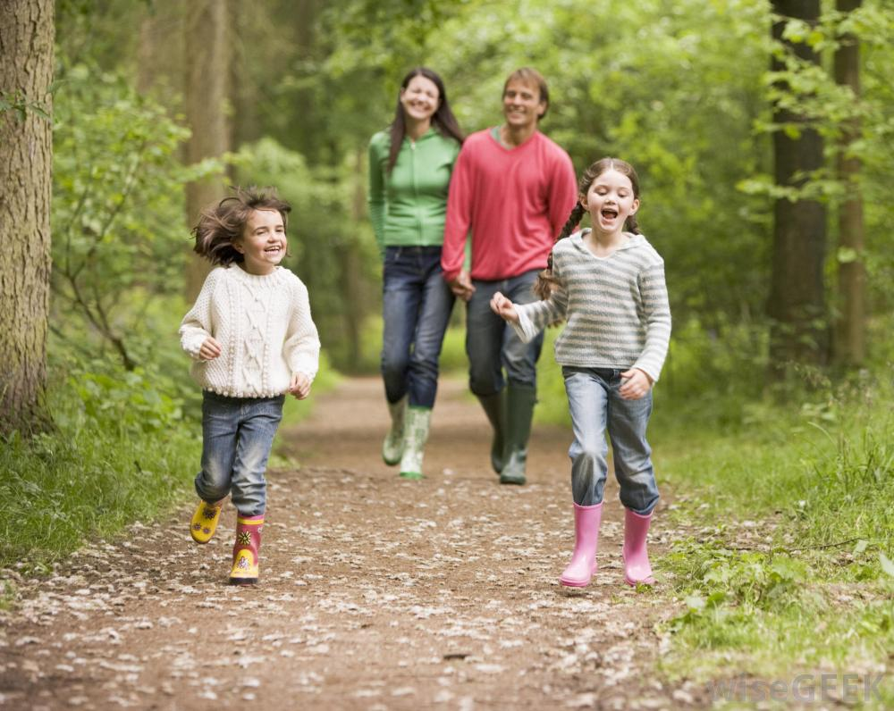

Woods are an exciting place to go for a walk with your family. There is a lot to explore and to see and hear. Here are some fun things to do.
- Take a bag with you and collect anything interesting. You might find leaves, pine cones, feathers, and twigs. You could make a picture with the things you find when you get home or just display them on a shelf or table.
- Balance and walk along some fallen logs with a grown up.
- Find a tree and give the trunk a hug. How does it feel?
- Take a camera and take some photos of anything you find interesting such as an animal or interesting tree. When you get home, look at your pictures and admire the beautiful wood.

Make some Healthy Edible Art

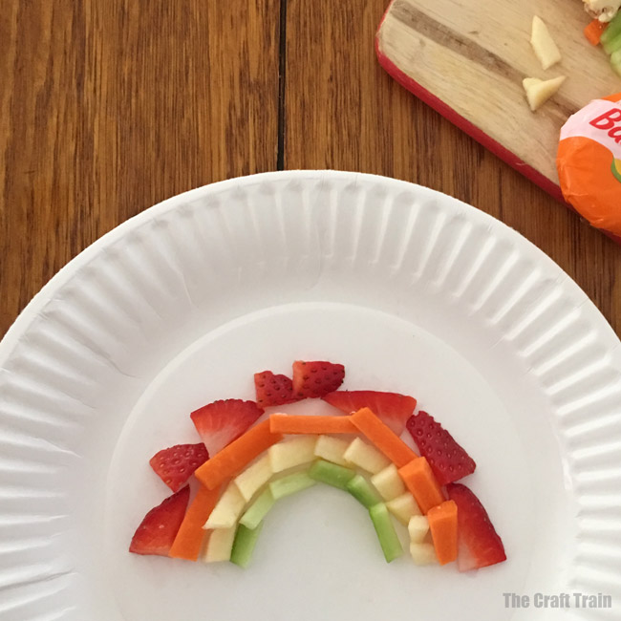

Chop up lots of pieces of healthy food. You may need a grown up to help.
This could be cucumber apple,cheese, strawberries, carrot, lettuce, ham, tomato, banana whatever you like best and you have in your fridge at home.
Make a rainbow shape on a plate or any other pattern you would like to make and enjoy eating it!

Clean and Tidy Your Room

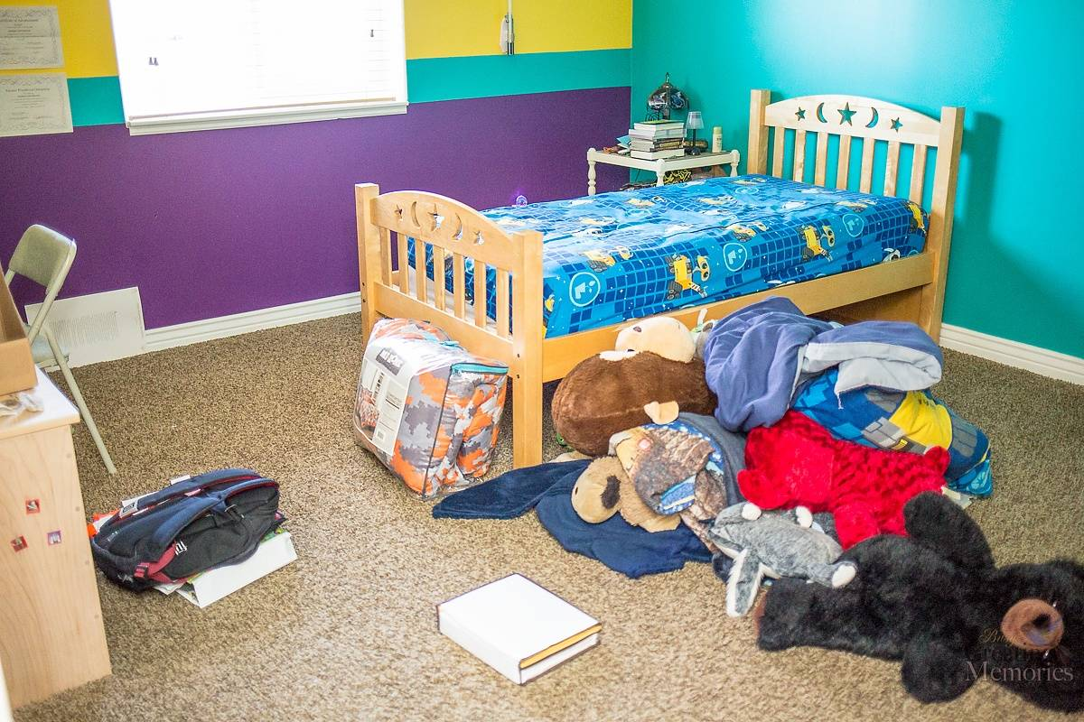

It is always nice to have a clean and tidy room. Put on a song and before it has finished see if you can….

- Put all your toys away neatly.
- Put dirty clothes in the washing bin and clean clothes in the drawers.
- Make your bed.

Well done! Maybe with an adults help try using the hoover to clean the floor and use a duster for the tops of shelves and cupboards.

I hope that was fun. Now, enjoy your lovely clean and tidy room!
Love from Mrs Graves

