How soap works to get rid of germs
- You will need 1 plate, black pepper and liquid soap.
- Pour some water onto the plate.
- Sprinkle some pepper on top of the water.
- Dip your finger in. What happens?
- Now put some liquid soap on the top of your finger and watch carefully as the pepper will spread out.
- This shows how when we use water the germs stay on our hands but when we use soap the germs are all washed away.
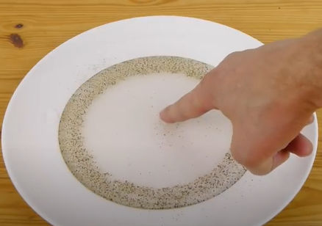
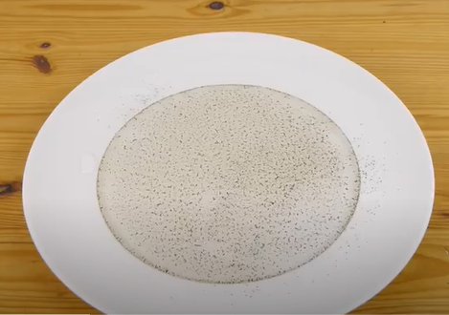
- Make sure you are using soap every time you wash your hands to get rid of germs.

