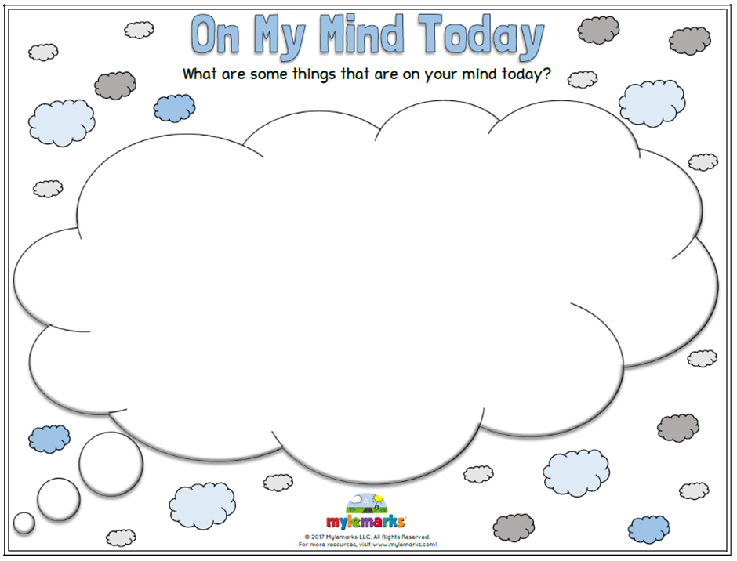

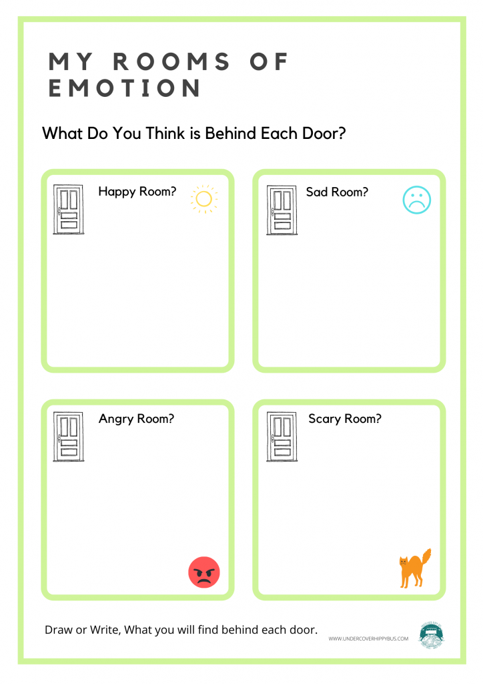

All about me
Draw a picture of yourself in the box below

Things I like about myself

……………………………………………………….

…………………………………………………………

…………………………………………………………

Things I am proud of

…………………………………………………………

………………………………………………………..

…………………………………………………………

Things I am good at

……………………………………………………….
…………………………………………………………
…………………………………………………………

Write down some of the things you have achieved recently

