Today’s activity is to make an Emotion wheel. D&T PSHE
The Colour Monster is very confused he doesn’t know how he is feeling.
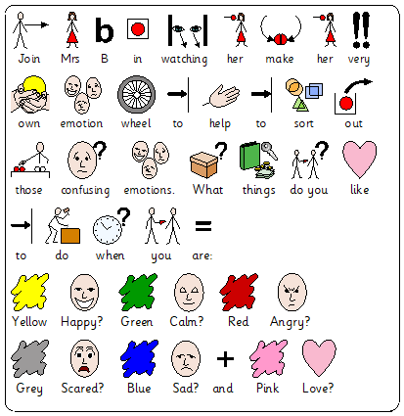
In Today’s D&T Video – Join Mrs B as she creates her own emotion wheel. She explores what it feels like to feel all of the emotions that the colour monster feels. She even makes not of things she likes to do for each colour and emotion. Why not have a talk about your emotions and things you like to do when you are:
Yellow Happy
Blue Sadness
Red Angry
Grey Scared
Green Calm
Pink Love

M Scales
PSHE - Relationships and living in the wider world
M9 - Pupils identify a range of feelings and emotions
M10 - Pupils name a range of feelings and emotions
M11 - Pupils accurately interpret a range of facial expressions
-Independence and Personal Wellbeing
M9 - Pupils can identify what makes them happy
M10 - Pupils identify when they feel unhappy or anxious
M11 - Pupils identify experiences which makes them feel anxious
D&T –
M9 - show that, with help, they can create products for a use and purpose, using their practical ideas.
M10 , M11 and M12 - They assemble, join and combine materials and components in a variety of ways to make functional products

