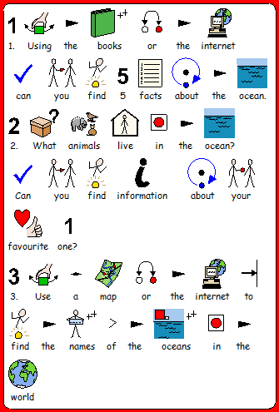
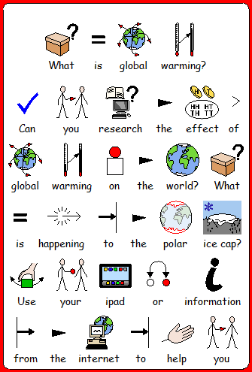
Extension Activity
M levels
M 11,12
They show an awareness of places beyond their own locality.
They carry out simple tasks and select information using resources that are given to them. They use this information and their own observations to help them ask and respond to questions about places and environments. They begin to use appropriate geographical vocabulary.
They express views on the environment of a locality and recognise how people affect the environment.
M13, 14, 15
They use skills and sources of evidence to respond to a range of geographical questions, and begin to use appropriate vocabulary to communicate their findings.

