M3 M4 Levels for The Very Hungry Caterpillar
Measure
Pupils explore objects of a range of sizes, weights, temperature. (M4)
Pupils listen to adults using words big, small, long, short, heavy, light, hot, cold. (M4)
- Give children different foods from the story of Hungry Caterpillar, model which are light (leaf, strawberry,etc) and which are heavy (apple, watermelon,etc) let children explore holding them.
- When eating at home, use vocabulary of hot and cold.
- When reading ‘The Hungry Caterpillar’ emphasise vocabulary big and small.
- Explore long and short with different foods.
Writing
They make marks or symbols in their preferred mode of communication. (M4)
Pupils make marks in a range of mediums and from a range of sensory stimuli. (M4)
- Make marks or symbols using different mediums, shaving foam, rice, flour.
- Use chalks or sponge paint outside
- Paint round stencil, reveal shape, letter, animal.
Reading
They show some understanding of how books work, for example, turning pages and holding the book the right way up. (M4)
Pupils match object to object. (M4)
- Share the ‘The very Hungry Caterpillar story’ together
- If you don’t have access to the book, watch it on you tube or watch the Robins team recreating the story – video found on website.
- Play matching game with foods from the story, either use pictures/symbols or real objects. Can the children find the same?
Speaking
Pupils respond to others with sounds and gestures. (M4)
Pupils observe others speaking and then repeat and imitate/copy up to ten words, signs or familiar short phrases. (M4)
Read ‘The Very Hungry Caterpillar Story’, show symbols of food or real objects encourage children to repeat word.
Listening
Pupil responds appropriately to simple requests, which contain one key word, sign or symbol in familiar situations, e.g. “Get your coat”, “Stand up” or “Clap your hands”. (M4)
Children listen to simple request, e.g. place fruits into fruit bowl one at a time.
Make a caterpillar out of cereal box/shoe box, can they feed the caterpillar. E.g. Apple in mouth, feed the caterpillar,
Science
Pupils cause movement by a pushing or pulling action. (M4)
Explore pushing and pulling with toys at home. Go outside on bikes and scooters, model how to push themselves along or to pull a bike along. Practice getting dressed - pulling up socks, pants, trousers.
Watch how the caterpillar pushes out of the cocoon, can they re-enact being the caterpillar?
PSHE
Pupils follow familiar routines and take part in familiar tasks or activities with full support from others. (M4) Pupils respond to a request with one key word in familiar situations.(M4)
Practice familiar routines within the home. E.g. getting dressed, bath time, tidying up
Pupils express their feelings, needs, likes and dislikes using single elements of communication (words, gestures, signs and symbols). (M4)
Giving children a choice of toys to play with, can they make a choice by exchanging a symbol or by saying word of toy. Or if they have made their choice by pointing, practice signing please
Try new and familiar foods together, model expressing like and dislike.
Humanities
Pupils know familiar places and people and what they are there for, for example, park, school, police person, and use gestures, signs, symbols or single words to show that they know them. M4
Look at pictures of familiar places, can they name them or match a symbol to them. These could even be places in the house, (sofa, bed, table, bath) take pictures of your child or their favourite toy in each place. Then show them, can they find the same place in the picture?
See symbols of familiar places on lower school lower home learning page.
Art and Design
Pupils repeat an activity to make the same or similar effect. M4
They show an active interest in a range of tools and materials, taking part in familiar activities with some support. M4
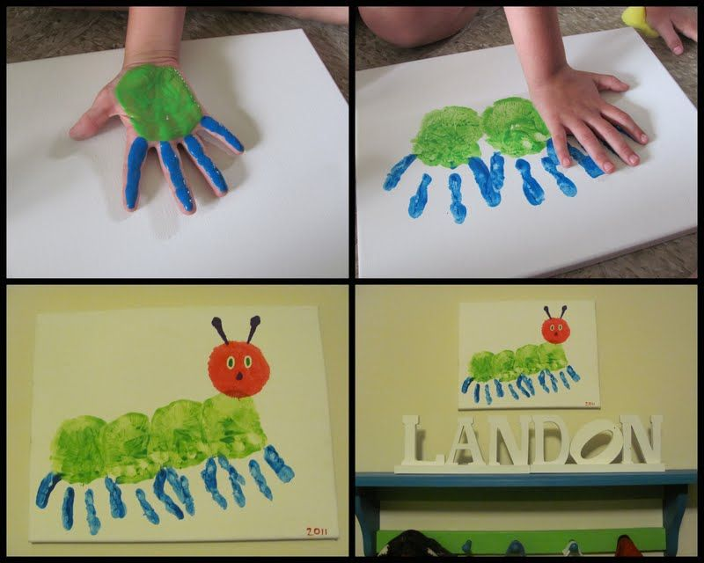
Explore printing with fruit and vegetables, dab them in paint and print them onto paper. Or you could you dab one cork into light green paint and another in dark green paint and make a hungry caterpillar painting. Or make a handprint hungry caterpillar painting!
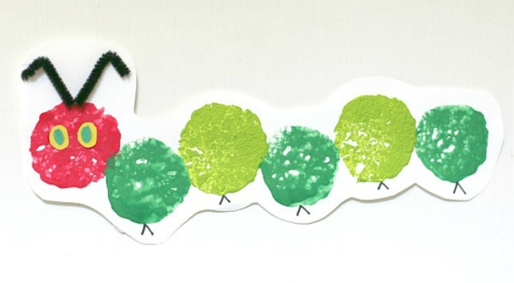

Cooking
They explore options within a limited range of materials, for example, adding grapes or chopped apple to a fruit salad. (M4)
Make a fruit salad using the fruits from the story. Can they chop up fruits and add them to bowl. (This may need to be hand over hand) Can they pour in juice at the end?
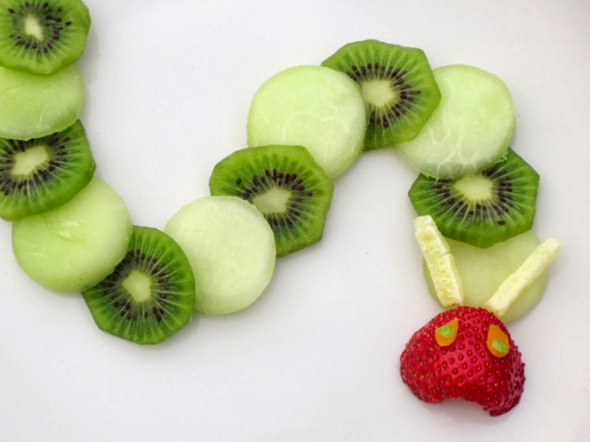
Make a Very Hungry Caterpillar out of foods.
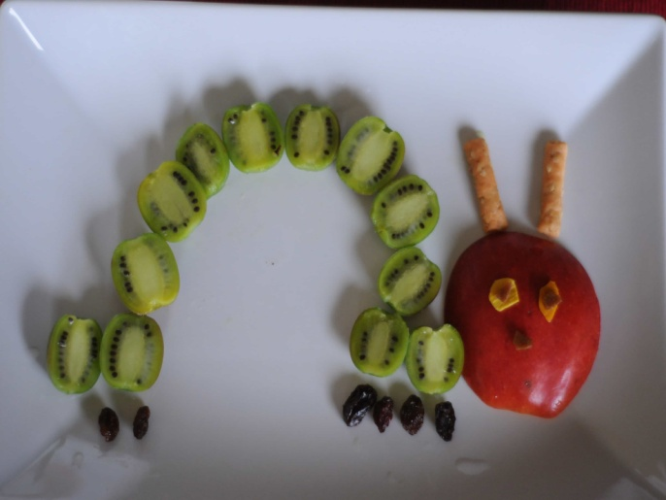
PE / Dance
Pupils’ movement patterns are established and they perform single actions, for example, rolling, running, jumping or crawling. (M4)
- Have your child pretend to be caterpillars and act out how they turn into butterflies by first curling up in a ball to represent the egg.
- Next, have them crawl out of the egg as a caterpillar and look for food.

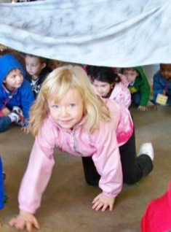
- Then have them crawl under a big blanket or sheet and roll them up like they are in a cocoon or chrysalis.
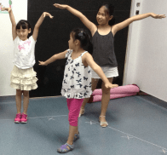
- Pull the sheet or blanket off and have them jump up and fly out like a butterfly.

