Today’s activity is to make a Feelings Jar PSHE
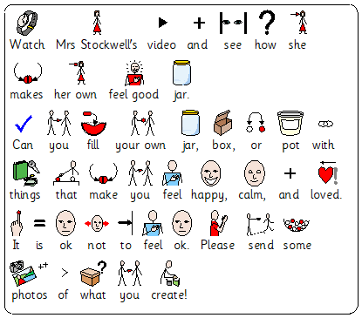
Watch Mrs Stockwell’s Video on how to make a Happy, Calm and Love Jar. For times when you are not feeling ok and you need something to make you smile and cheer up. This Jar will have words, pictures, and treats that will help you to feel better.

M Scales PSHE Independence and personal well being
M9 - Pupils can identify what makes them happy
M10 - Pupils identify when they feel unhappy or anxious
M11 - Pupils identify experiences which makes them feel anxious
Relationships and Living in the Wider World
M9 - Pupils listen to suggestions as to how to manage their feelings in a positive manner
M10 - Pupils name a range of feelings and emotions. Pupils seek help for others in distress
M11 - Pupils suggest how feelings can be managed in a positive manner

