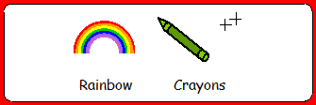

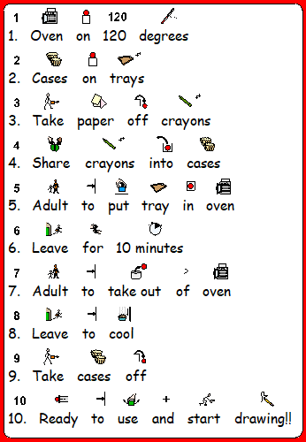
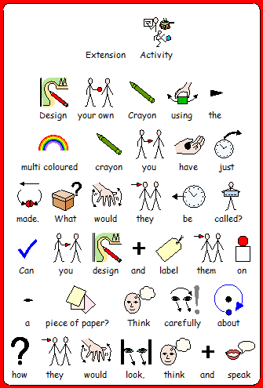
Art and Design M11 M12

Pupils explore ideas and make some choices about what they will do.
M13 14 15
Pupils explore ideas in different ways, collecting information and practical resources in order to make informed choices about their work

