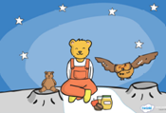
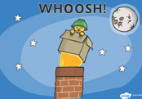
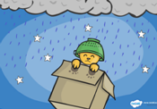
Watch or look at the story of Whatever Next and cut out pictures for children to sequence.
Encourage children to talk about what is happening in each picture and introduce the language beginning, middle and end.

