The Colour Monster Overview
This term we are learning about The Colour Monster story. This is a wonderful story that focuses on emotions. We thought this story would help to support the children through these unpredictable, ever changing times.
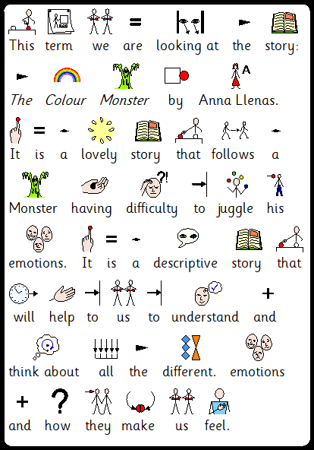

Here is the link to the story. https://www.youtube.com/watch?v=Ih0iu80u04Y
The Colour Monster mainly focuses on emotional and how each emotion can make you feel.
Please read through the story and talk about the different feeling throughout.

We have put together a selection of activities that support many areas of the curriculum.
Here is an overview to the different activities that we encourage that you select and try if and when you can.
Many of which are done through video.
Activity 1 English - writing: Character descriptions. Help to use similes to describe the different colour monsters.
Activity 2 D&T and PSHE: Emotion Wheel. (Video) Make an emotion wheel that can act as a supporting aid when trying to say how you are feeling.
Activity 3 Science and Art: Colour Mixing. (Video). Watch and predict what will happen when you mix different colours. Have fun in exploring mixing colours using different ways.
Activity 4 PSHE: Feelings Jar. (Video) Create your own jar that helps you to feel, happy calm and loved.
Activity 5: PE, PSHE, Drama, Speaking and Listening. (Video). Follow instruction to move into different yoga positions. Explore different emotions using Drama.
Activity 6: Art, Speaking and Listening. (Video) Follow a tutorial to draw the colour Monster.

