The Very Hungry Caterpillar

Welcome to Lower School Remote Learning area. In Lower School we have chosen to provide activities through a well known and much loved story – The Very Hungry Caterpillar.
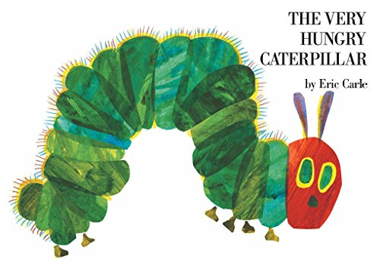
To use the resources you will first have been guided by your child’s class teacher to the ability area for your child this will be either lower, middle or higher ability. Once in this folder you will be able to access resources for the following curriculum areas; maths measure, writing, reading, speaking and listening, PSHE, humanities, art and design, cooking and PE.
You can choose to watch the story here or share the book with your child. Once you have done this you can dip into any of the curriculum areas to have a go at some fun learning at home!

