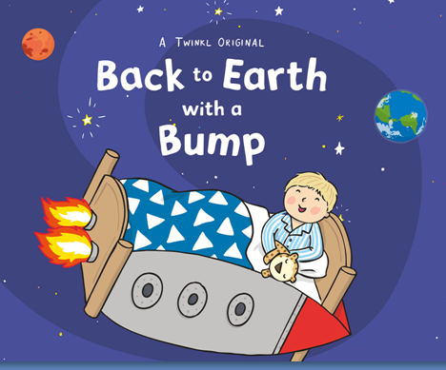

Learning objectives
To listen and respond to a story – Use the ‘Talking cards’ resource to talk about the story.
To use familiar story book language within play and discussion – Use the Word mat to learn key words from the story.
To use language to recreate roles and experiences – Watch the Puppet show version of the story on the Middleton Youtube channel.
To develop mark making or emergent writing – Use the Emergent writing template to generate a sentence.

English
- Use the ‘Thought bubbles resource’ to explain what Hal might be thinking in some of the illustrations from the story.
- Sequencing what happened in the story

Maths
- Make your own Planets
- Can you draw a picture of a Rocket bed
- Matching pictures and words – Use the ‘Boards and pictures’ and ‘Cards and words’ resources
- Writing lists of what Hal could take to space with him

Design Technology
- Design and make a rocket for Hal to use instead of a bed.

Art
- Make some of the planets from the solar system.

