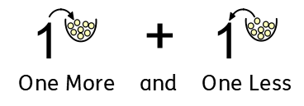

|  |  |  |
| --- | --- | --- |
|  |  |  |
|  |  |  |

0 1 2 3 4 5 6 7 8 9 0 1 2 3 4 5 6 7 8 9