D & T covers designing and creating with craft resources as well as cooking. These are all activities that encourage fine motor control and creative development as well as Design and Technology skills. Skills such as cutting, joining, making choices, and making mistakes are key skills in D&T and life! The activities below and in this folder are creative and vary in difficulty- enjoy!

1. Build a bridge activity- see in folder information and prompt card
An alternative to adapt the story is build a raft as below:
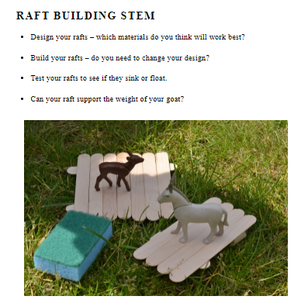
2. Cardboard tube craft Goats
Create your own Goats using cardboard tubes Follow the following link to the laughing kids learn website and scroll down for the resources and instructions
https://laughingkidslearn.com/billy-goats-gruff-craft-idea-for-kids
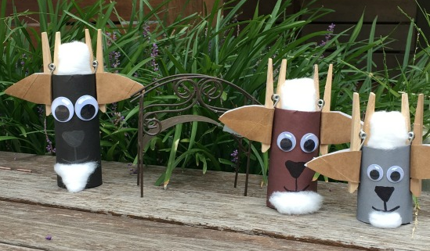
3. Make a split pin or stick puppet to practice some cutting and joining skills- See Split pin or stick puppet PDF’s in folder.
4. Cooking ideas
I loved watching ‘Big cook, Little cook’ with my boys and have managed to find an episode that includes the 3 Billy Goat story and cooking activity. Use the following link to access, watch and make a Baguette Bridge https://www.youtube.com/watch?v=qrc2MzlMjwM

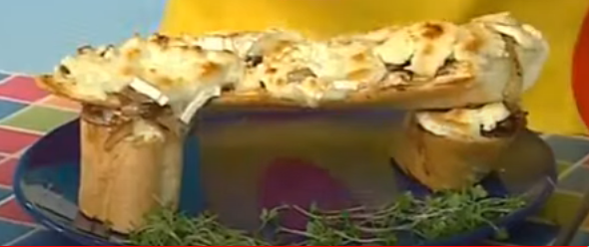
Ingredients
2 Onions thinly sliced
Cress a little for decoration
2 tbsp oil
1 tbsp sugar
3 tbsp cider vinegar
1 Baguette cut into 3 pieces 2 short 1 long
Goats Cheese 5 slices
This Troll Toe Biscuits recipe I found looks great although it makes 60 apparently so you may want to halve or quarter all the ingredients.
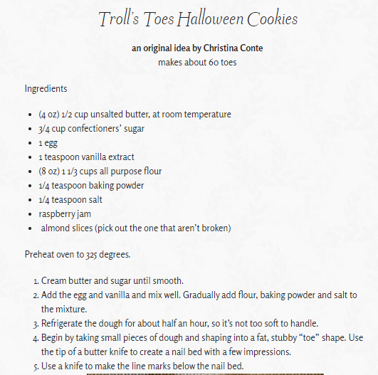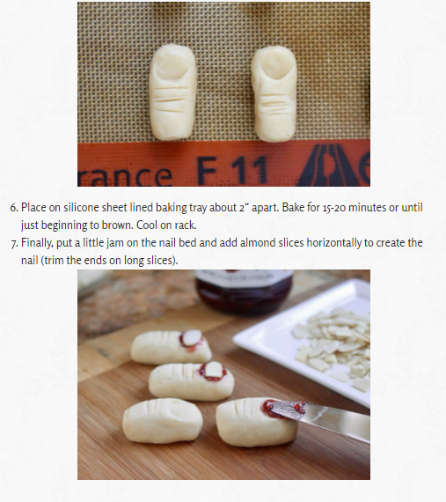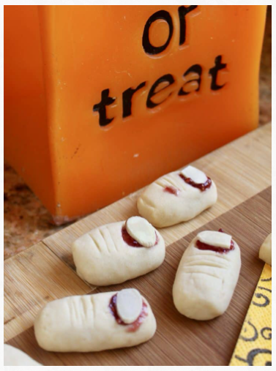
Troll Toe Biscuits
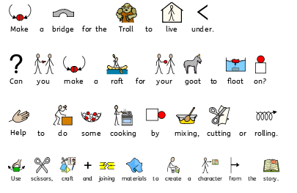
Design and Technology M6
Pupils recognise familiar products and explore the different parts they are made from. They watch others using a basic tool and copy the actions, for example, preparing a surface with a glass paper block. They begin to offer responses to making activities, for example, suggesting the colour or shape of a product.

Design and Technology M7
Pupils operate familiar products, with support, and explore how they work. They use basic tools or equipment in simple processes, chosen in negotiation with staff, for example, in cutting or shaping materials. They begin to communicate preferences in their designing and making, for example, adding selected felt shapes to fabric.

Design and Technology M8
Pupils explore familiar products and communicate views about them when prompted. With help, they manipulate a wider range of basic tools in making activities, for example, joining components together to make their intended product. They begin to contribute to decisions about what they will do and how, for example, communicating their approval of certain features of a process.

